**Practical No 1**

**Problem Statement: Working with basic C# and ASP .NET**

**a. Create an application that obtains four int values from the user and displays the product.**

**Source Code:- Prac1.cs:**

using System;

using System.Collections.Generic;

using System.Linq;

using System.Text;

using System.Threading.Tasks;

namespace prac1a

{

class Program

{

static void Main(string[] args)

{

int n1, n2, n3, n4, p;

Console.WriteLine("enter four number:");

n1 = Convert.ToInt32(Console.ReadLine());

n2 = Convert.ToInt32(Console.ReadLine());

n3 = Convert.ToInt32(Console.ReadLine());

n4 = Convert.ToInt32(Console.ReadLine());

p = n1 * n2 * n3 * n4;

Console.WriteLine("Product:" + p);

Console.ReadKey();

} }

}

**Output:**

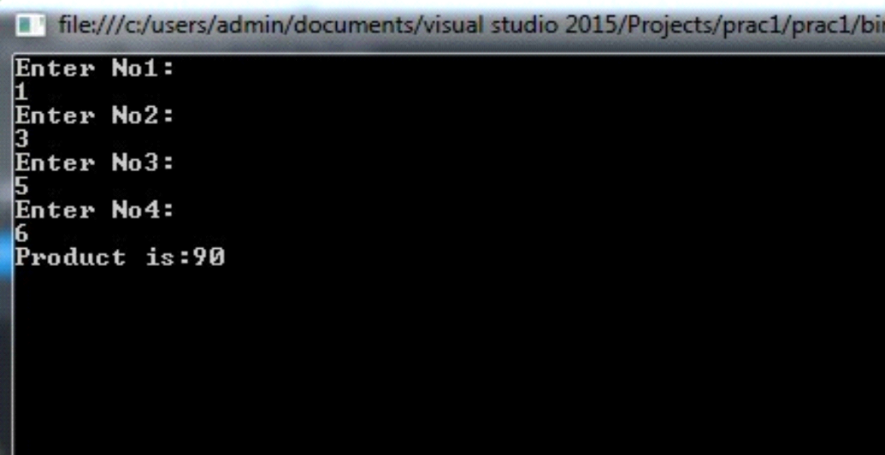

**b. Create an application to demonstrate string operations.**

**Source Code:- Pract1B.cs:**

using System;

using System.Collections.Generic;

using System.Linq;

using System.Text;

using System.Threading.Tasks;

namespace pract1B

{

class Program {

static void Main(string[] args)

{

String a = "sandeep";

String b = "pokharkar";

Console.WriteLine(a.Contains("and"));

Console.WriteLine(a.Equals(b));

Console.WriteLine(a.Length);

Console.WriteLine(a.GetType());

Console.WriteLine(a.Replace('e', 'i'));

Console.WriteLine(a.ToUpper());

Console.ReadKey();

}

} }

**Output:-**

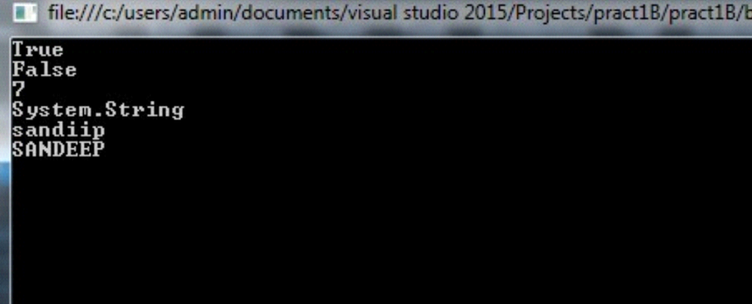

**C. Create an application that receives the (Student Id, Student Name, Course Name, Date of Birth) information from a set of students. The application should also display the information of all the students once the data entered.**

**Source Code:- Pract1c.cs:**

using System;

using System.Collections.Generic;

using System.Linq;

using System.Text;

using System.Threading.Tasks;

namespace pract1C

{

class Program

{

public struct Student

{

public string StudID;

public string StudName;

public stringCourseName;

public string DOB;

}

static void Main(string[] args)

{

Student[] stud = new Student[2];

Console.WriteLine("Enter the Student details:");

for (int i = 0; i < 2; i++)

{

Console.WriteLine();

Console.WriteLine("Enter Student ID:");

stud[i].StudID = Console.ReadLine();

Console.WriteLine("Enter Student Name:");

stud[i].StudName = Console.ReadLine();

Console.WriteLine("Enter Student Course Name:");

stud[i].CourseName = Console.ReadLine();

Console.WriteLine("Enter Student DOB:");

stud[i].DOB = Console.ReadLine();

}

Console.WriteLine();

Console.WriteLine();

Console.WriteLine("Student details:");

for (int i = 0; i < 2; i++)

{

Console.WriteLine();

Console.WriteLine("Student ID:{0}", stud[i].StudID);

Console.WriteLine("Student Name:{0}", stud[i].StudName);

Console.WriteLine("Student Course Name:{0}", stud[i].CourseName);

Console.WriteLine("Student DOB:{0}", stud[i].DOB);

}

Console.ReadKey();

}

}

}

**Output:-**

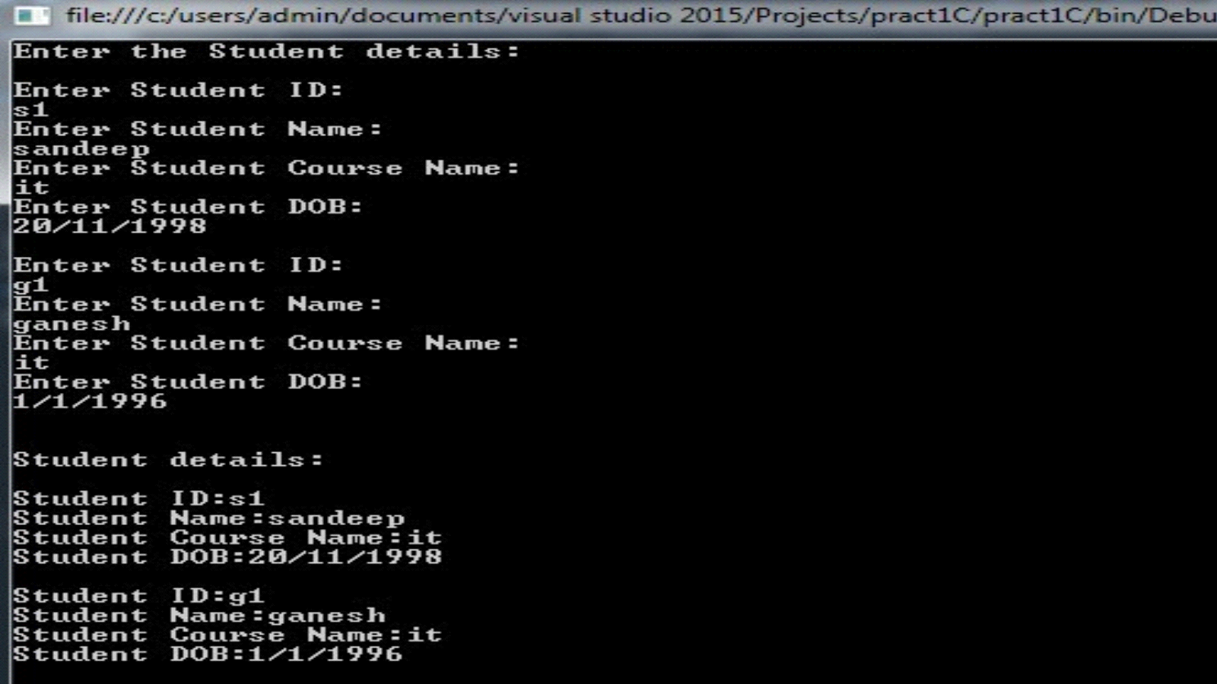

**d. Create an application to demonstrate following**

**i. Generate Fibonacci series.**

**SorceCode:**

using System;

using System.Collections.Generic;

using System.Linq;

using System.Text;

using System.Threading.Tasks;

namespace fibonacci_series

{

class Program

{

static void Main(string[] args)

{

int a = 0, b = 1, c;

Console.WriteLine("Fibonacci series are:" + a);

Console.WriteLine(b);

for (int i = 0; i < 10; i++)

{

c = a + b;

Console.WriteLine(c);

a = b; b = c;

}

Console.ReadKey();

}

}

}

**Output:**

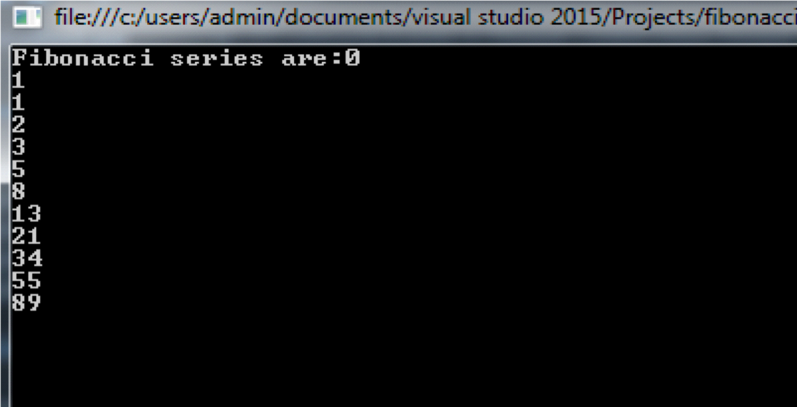

**ii. Test for prime numbers.**

**Source code:**

using System;

using System.Collections.Generic;

using System.Linq;

using System.Text;

using System.Threading.Tasks;

namespace prime_no

{

class Program

{

static void Main(string[] args)

{

int n, i;

Console.WriteLine("Enter the number:");

n = int.Parse(Console.ReadLine());

for (i = 2; i < n; i++)

{

if (n % i == 0)

{

Console.WriteLine("It is not a prime number", n);

break;

}

}

if (i == n)

{

Console.WriteLine("It is a prime number", n);

}

Console.ReadKey();

}

}

}

**Output:**

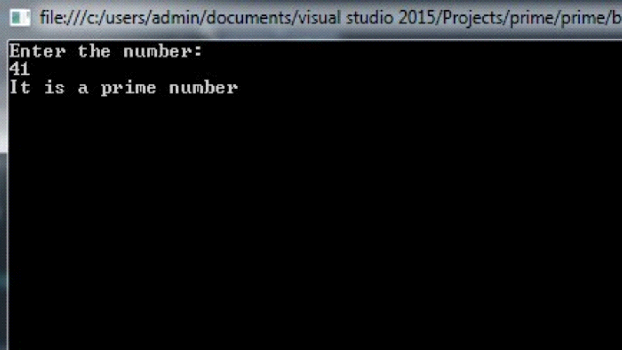

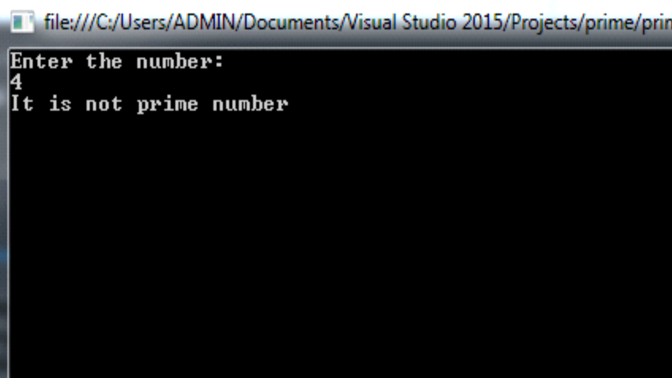

**iii. Test for vowels.**

**SourceCode:**

using System;

using System.Collections.Generic;

using System.Linq;

using System.Text;

using System.Threading.Tasks;

namespace vowels

{

class Program

{

static void Main(string[] args)

{

char c;

Console.WriteLine("Enter any charater:");

c = Convert.ToChar(Console.ReadLine());

switch (c)

{

case 'a':

case 'e':

case 'i':

case 'o':

case 'u':

case 'A':

case 'E':

case 'I':

case 'O':

case 'U':

Console.Write("It is a vowel");

break;

default:

Console.Write("It is consonant character");

break;

}

Console.ReadKey();

}

}

}

**Output:**

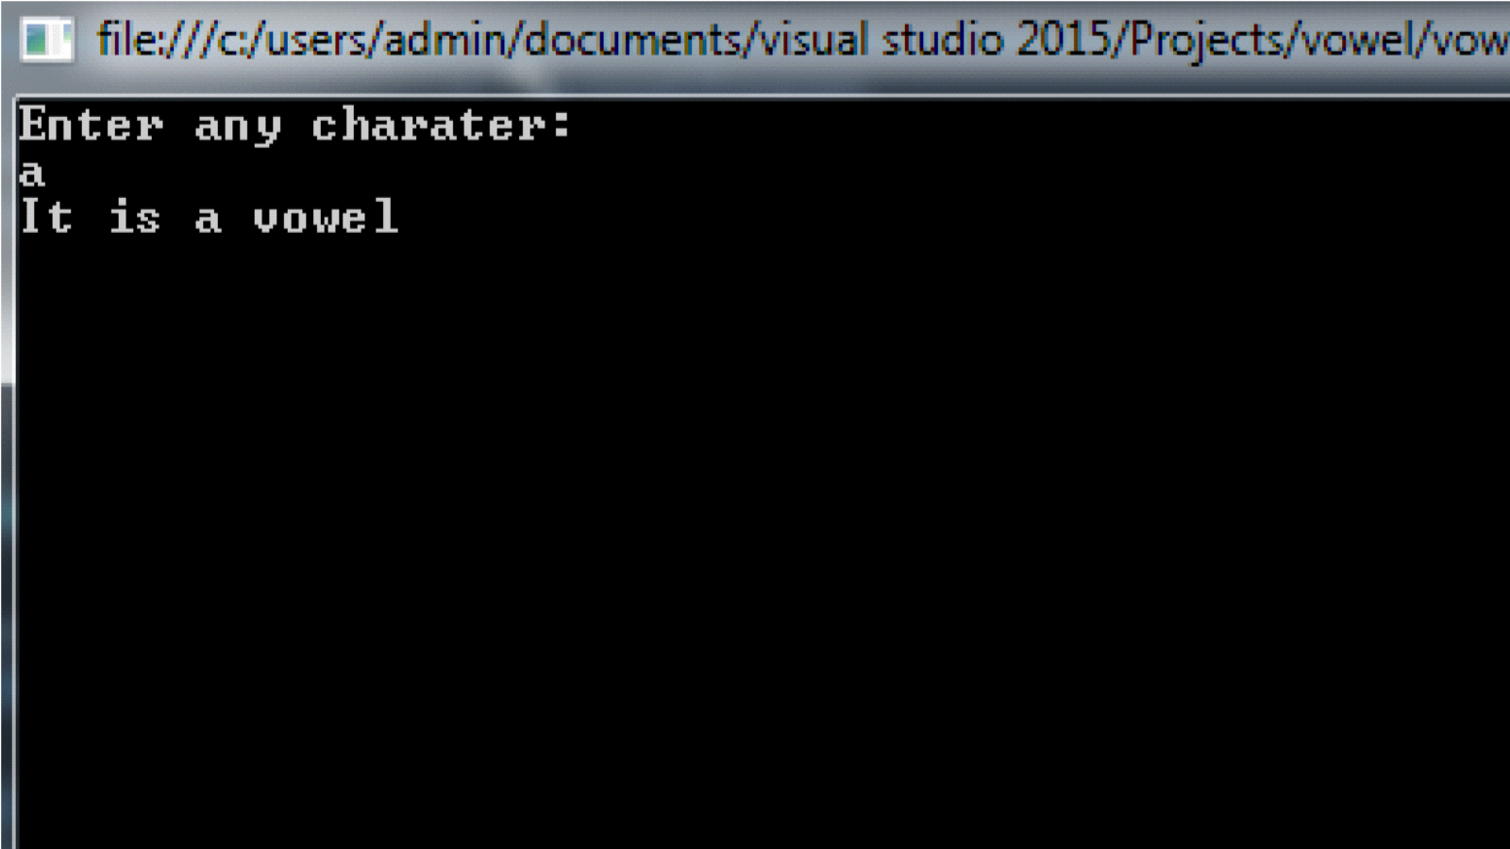

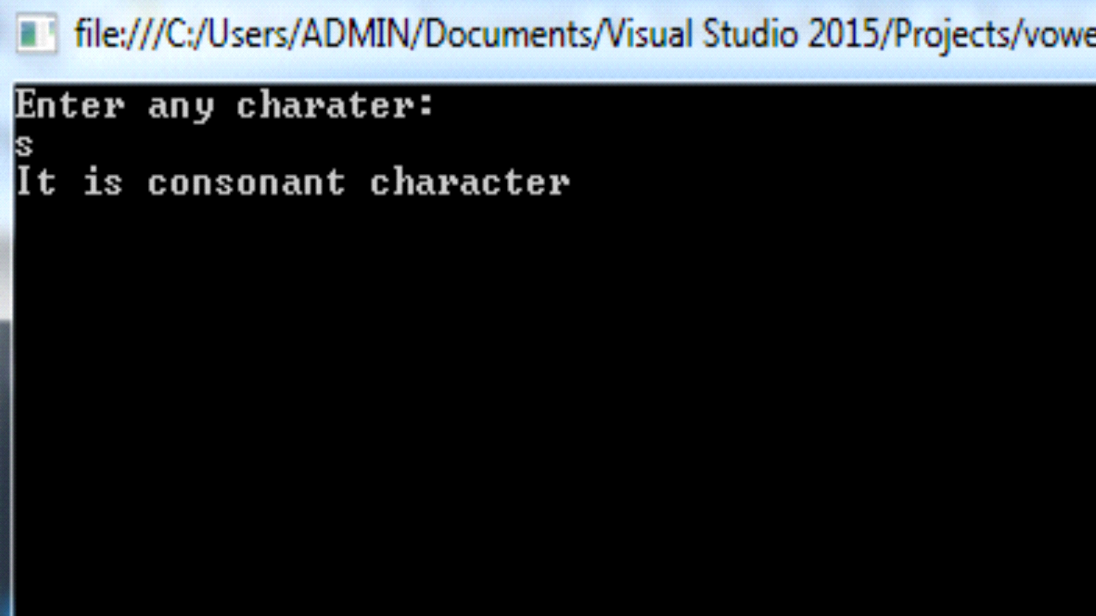

**iv. Use of foreach loop with arrays**

**Source Code:**

using System;

using System.Collections.Generic;

using System.Linq;

using System.Text;

using System.Threading.Tasks;

namespace foreach_loop

{

class Program

{

static void Main(string[] args)

{

int[] arr1 = new int[3] { 1, 2, 3 };

string[] arr2 = new string[3] { "SANDEEP", "GANESH", "SANDY" };

Console.WriteLine("Elements in first array :");

foreach (int i in arr1)

{

Console.WriteLine(i);

}

Console.WriteLine();

Console.WriteLine("Elements in second array :");

foreach (string i in arr2)

{

Console.WriteLine(i);

}

Console.ReadKey();

} }

}

**Output:**

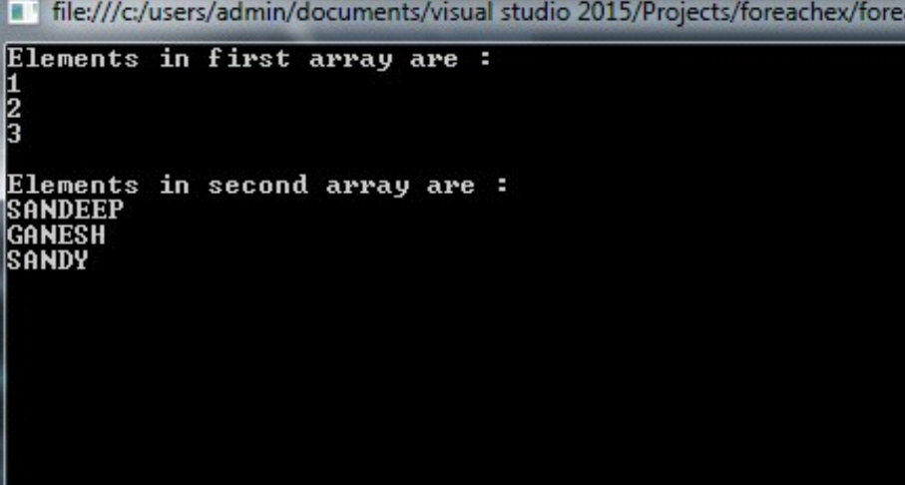

**v. Reverse a number and find sum of digits of a number.**

**Source Code:**

using System;

using System.Collections.Generic;

using System.Linq;

using System.Text;

using System.Threading.Tasks;

namespace reverse_no

{

class Program

{

static void Main(string[] args)

{

Console.WriteLine("Enter the number:");

int n, sum = 0, rev = 0;

int d = 0;

n = int.Parse(Console.ReadLine());

int m = n;

Console.WriteLine();

Console.WriteLine("Reverse number is :");

while (n != 0)

{

d = n % 10;

rev = rev * 10 + d;

n = n / 10;

}

Console.WriteLine(rev);

Console.WriteLine("Sum of the number is:");

while (m != 0)

{

d = m % 10;

sum = sum + d; m = m / 10;

}

Console.WriteLine(sum);

Console.ReadKey();

}

}

}

**Output:**

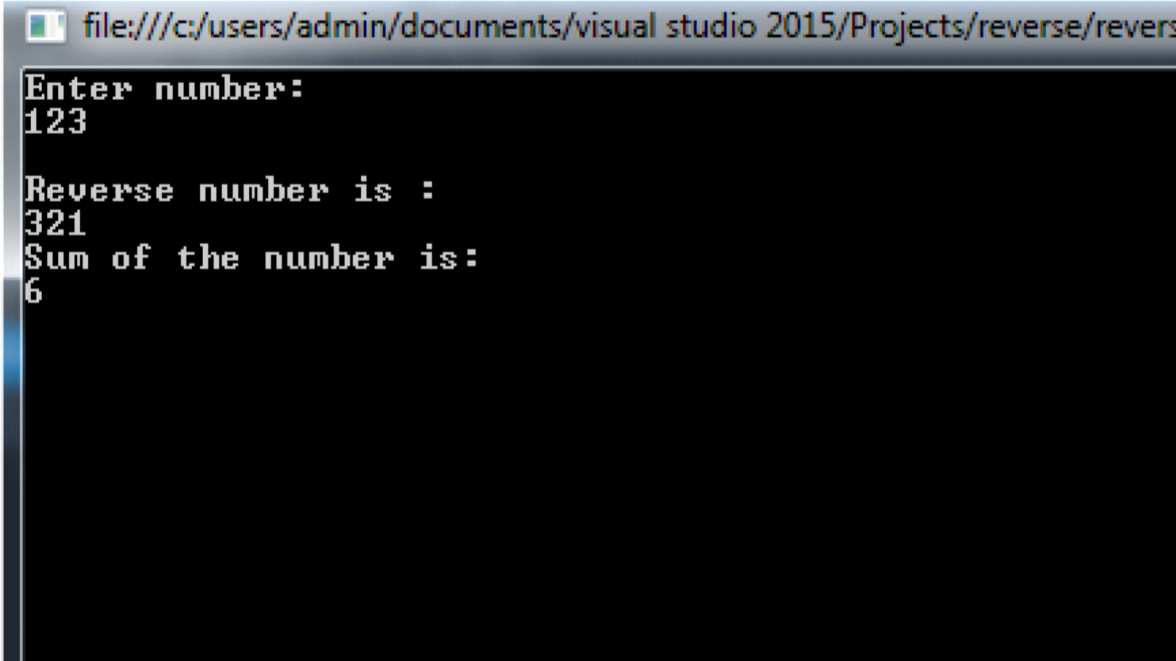

**Practical no 2.**

**Problrm statement: Working with Object Oriented C# and ASP .NET**

**a.Create simple application to perform following operations**

**i.Finding factorial Value**

**Source Code:**

using System;

using System.Collections.Generic;

using System.Linq;

using System.Text;

using System.Threading.Tasks;

namespace factorial_no

{

class Program

{

static void Main(string[] args)

{

int i, n, f = 1;

Console.WriteLine("enter any no:");

n = int.Parse(Console.ReadLine());

for (i = 1; i <= n; i++)

{

f = f * i;

}

Console.WriteLine("factorial=" + f);

Console.ReadKey();

}}

}

**Output:**

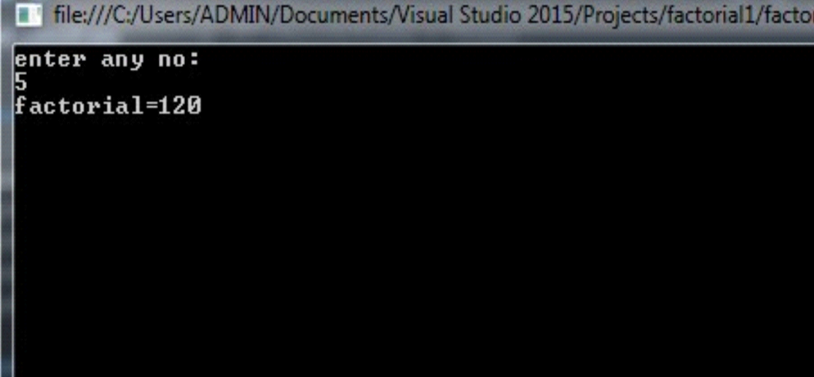

**ii.Money Conversion**

**SourceCode**

using System;

using System.Collections.Generic;

using System.Linq;

using System.Text;

using System.Threading.Tasks;

namespace money

{

class Program

{

public double Dolr(double r)

{

r = r * 0.015;

return r;

}

public double Euros(double r)

{

r = r * 0.012;

return r;

}

public double Pound(double r)

{

r = r * 0.011;

return r;

}

public double Yen(double r)

{

r = r * 1.164;

return r;

}

static void Main(string[] args)

{

Program p = new Program();

Double dollar, rupee, euro,pound,j;

Console.WriteLine("enter rupee value");

rupee = double.Parse(Console.ReadLine());

dollar = p.Dolr(rupee);

euro = p.Euros(rupee);

pound = p.Pound(rupee);

j = p.Yen(rupee);

Console.WriteLine("{0} rupees equals {1} dollar", rupee, dollar);

Console.WriteLine("{0} rupees equals {1} euro", rupee, euro);

Console.WriteLine("{0} rupees equals {1} pound", rupee, pound);

Console.WriteLine("{0} rupees equals {1} japanese yen", rupee,j);

Console.ReadKey();

}

}

}

**Output:**

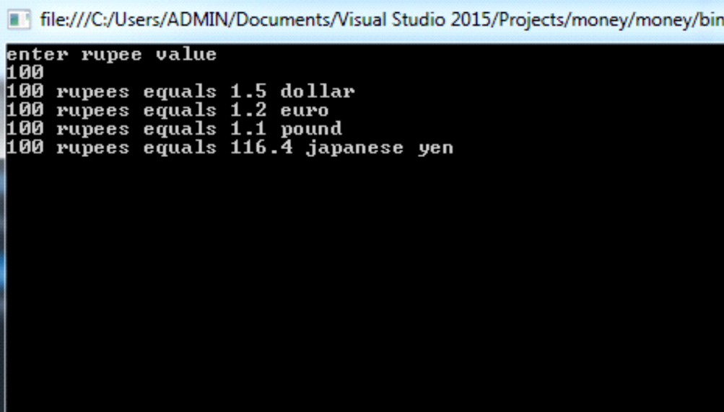

**iii.Quadratic Equation**

**Source Code:**

using System;

using System.Collections.Generic;

using System.Linq;

using System.Text;

using System.Threading.Tasks;

namespace quadratic

{

class Program

{

static void Main(string[] args)

{

int a, b, c, d;

double d1, r1, r2;

Console.WriteLine("Enter the value of a , b, c");

a = int.Parse(Console.ReadLine());

b = int.Parse(Console.ReadLine());

c = int.Parse(Console.ReadLine());

d = (b * b) - (4 * a * c);

d1 = Math.Sqrt(d);

if (d1 > 0)

{

r1 = (-b + d1) / (2 * a);

r2 = (-b - d1) / (2 * a);

Console.WriteLine("R1 =" + r1);

Console.WriteLine("R2 =" + r2);

}

else

{

Console.WriteLine("roots are imaginary");

}

Console.ReadKey();

} }}

**Output:**

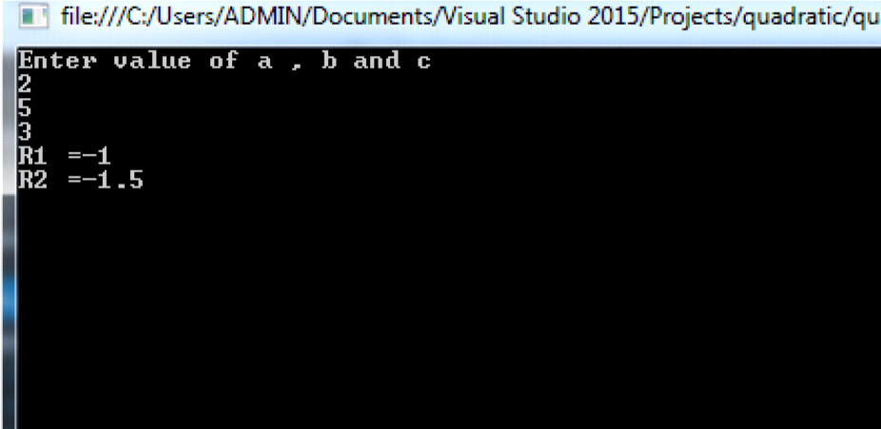

**Iv.Temperature Conversion**

**Source Code:**

using System;

using System.Collections.Generic;

using System.Linq;

using System.Text;

using System.Threading.Tasks;

namespace temperature

{

class Program

{

static void Main(string[] args)

{

double a, b;

convert c= new convert();

Console.WriteLine("enter celsius temprature to convert fahrenheit");

a = c.convertctof(100);

Console.WriteLine(a);

Console.WriteLine("enter fahrenheit temprature to convert celsius");

b = c.convertftoc(50);

Console.WriteLine(b);

Console.ReadKey();

}

}

class convert

{

public double convertctof(double c)

{

return ((9.0 / 5.0) * c) + 32;

}

public double convertftoc(double f)

{

return ((9.0 / 5.0) * (f - 32));

}}}

**Output:**

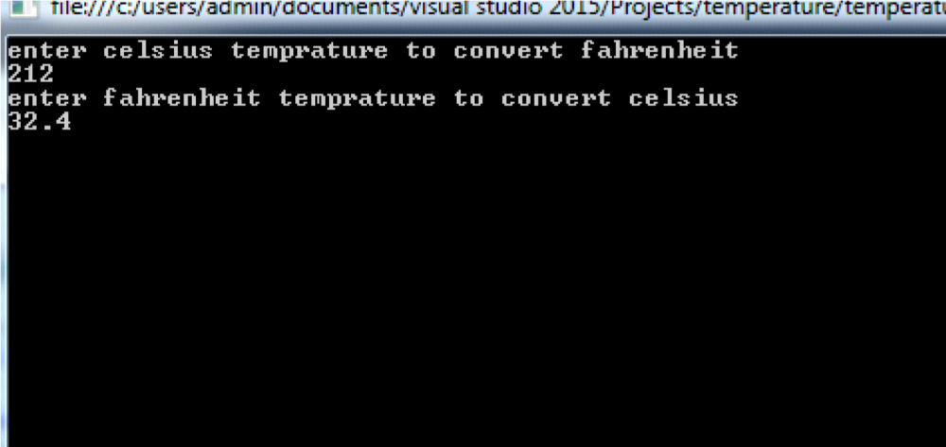

**b. Create simple application to demonstrate use of following concepts**

**i.Function Overloading**

**Source Code:**

using System;

using System.Collections.Generic;

using System.Linq;

using System.Text;

using System.Threading.Tasks;

namespace func_overloading

{

class Program

{

public void area(int a)

{

int s;

s = a * a;

Console.WriteLine("Area of square" + s);

}

public void area(int l, int b)

{

int r;

r = l * b;

Console.WriteLine("Area of reactangle" + r);

}

static void Main(string[] args)

{

Program p = new Program();

p.area()2;

p.area(5, 4);

Console.ReadKey();

}

}

}

**Output:**

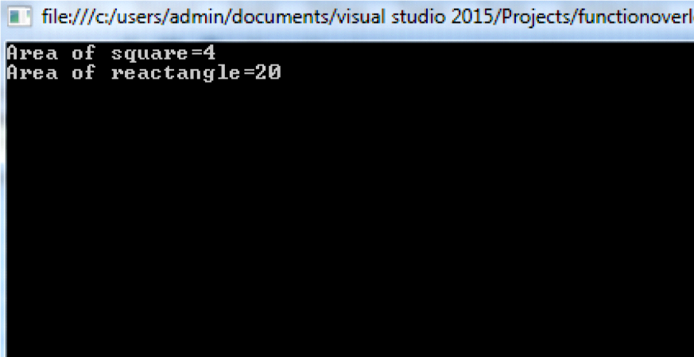

**ii. Inheritance (all types)**

**Source Code:sinlelevel.cs**

using System;

using System.Collections.Generic;

using System.Linq;

using System.Text;

using System.Threading.Tasks;

namespace single_inheri

{

class Program

{

static void Main(string[] args)

{

B b1 = new B();

b1.disp();

b1.disp1();

Console.ReadKey();

}

}

class A

{

public void disp()

{

Console.WriteLine("this is class A ");

}

}

class B : A

{

public void disp1()

{

Console.WriteLine("this is class B derived from class A");

}

}

}

**Output:**

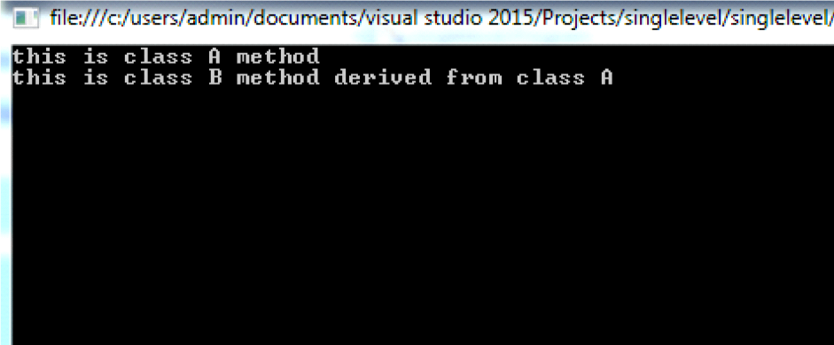

**Source Code:Multilevel.cs**

using System;

using System.Collections.Generic;

using System.Linq;

using System.Text;

using System.Threading.Tasks;

namespace multilevel

{

class Program

{

static void Main(string[] args)

{

C c1 = new C();

c1.disp();

c1.disp1();

c1.disp2();

Console.ReadKey();

}

}

class A

{

public void disp()

{

Console.WriteLine("this is class A ");

}

}

class B : A

{

public void disp1()

{

Console.WriteLine("this is class B derived from class A");

}

}

class C : B

{

public void disp2()

{

Console.WriteLine("this is class C derived from class B");

}

}

}

**Output:**

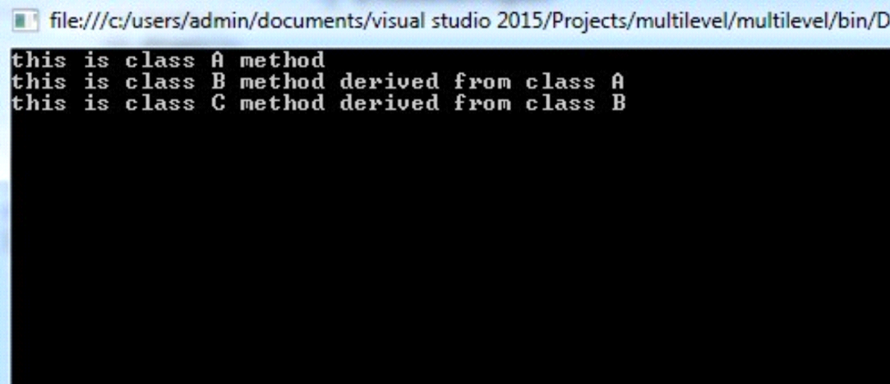

**Source Code:hierarchicallevel.cs**

using System;

using System.Collections.Generic;

using System.Linq;

using System.Text;

using System.Threading.Tasks;

namespace hierarchical

{

class Program

{

static void Main(string[] args)

{

C c1 = new C();

c1.disp();

c1.disp2();

B b1 = new B();

b1.disp();

b1.disp1();

Console.ReadKey();

}

}

class A

{

public void disp()

{

Console.WriteLine("this is class A");

}

}

class B : A

{

public void disp1()

{

Console.WriteLine("this is class B derived from class A");

}

}

class C : A

{

public void disp2()

{

Console.WriteLine("this is class C derived from class A");

}

}

}

**Output:**

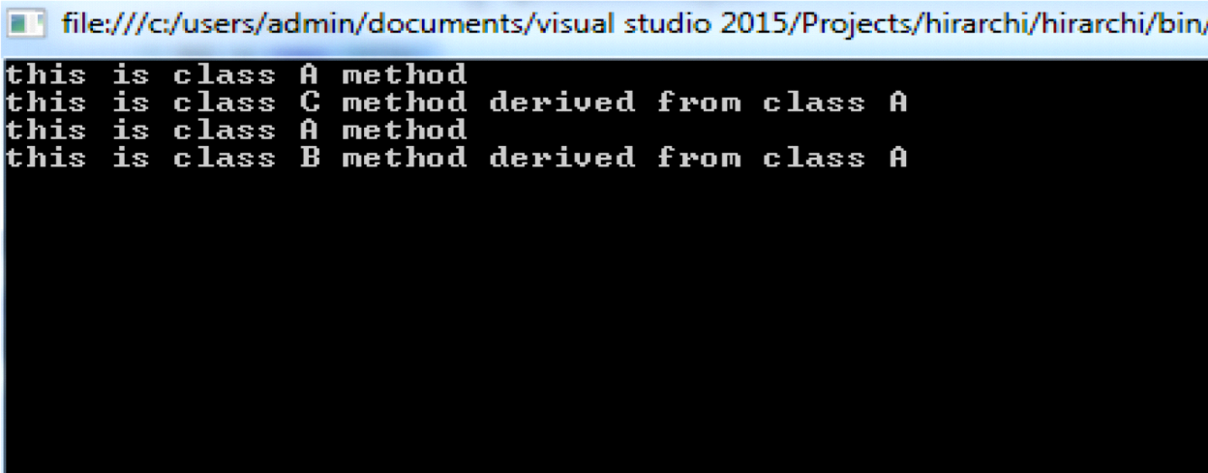

**Source Code:multiplelevel.cs**

using System;

using System.Collections.Generic;

using System.Linq;

using System.Text;

using System.Threading.Tasks;

namespace multiple_level

{

class Program

{

static void Main(string[] args)

{

C c1 = new C();

c1.disp();

c1.disp1();

c1.disp2();

Console.ReadKey();

}

}

class A

{

public void disp()

{

Console.WriteLine("this is class A ");

}

}

interface B

{

void disp1();

}

class C : A, B

{

public void disp2()

{

Console.WriteLine("this is class C derived from class A and interface B");

}

public void disp1()

{

Console.WriteLine("this is interface");

} }}

**Output:**

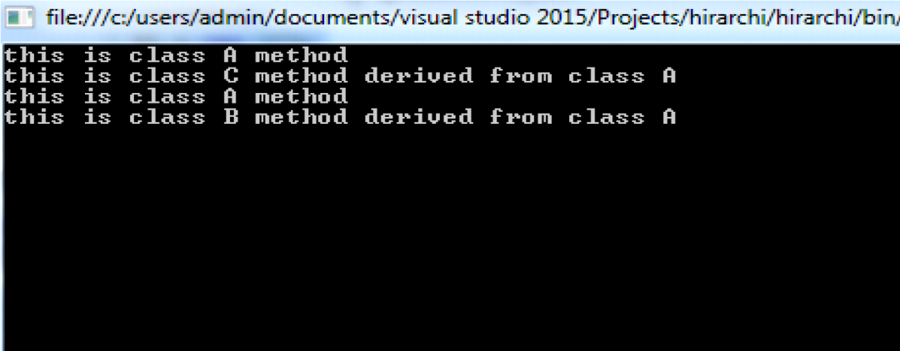

**SourceCode:Hybridlevel.cs**

using System;

using System.Collections.Generic;

using System.Linq;

using System.Text;

using System.Threading.Tasks;

namespace hybrid_level

{

class Program

{

static void Main(string[] args)

{

D d1 = new D();

d1.disp();

d1.disp1();

d1.disp2();

C c1 = new C();

c1.disp();

c1.disp3();

Console.ReadKey();

}

}

class A

{

public void disp()

{

Console.WriteLine("this is class A ");

}

}

class B : A

{

public void disp1()

{

Console.WriteLine("this is class B derived from class A");

}

}

class D : B

{

public void disp2()

{

Console.WriteLine("this is class D derived from class B");

}

}

class C : A

{

public void disp3()

{

Console.WriteLine("this is class C derived from class A");

}

}

}

**Output:**

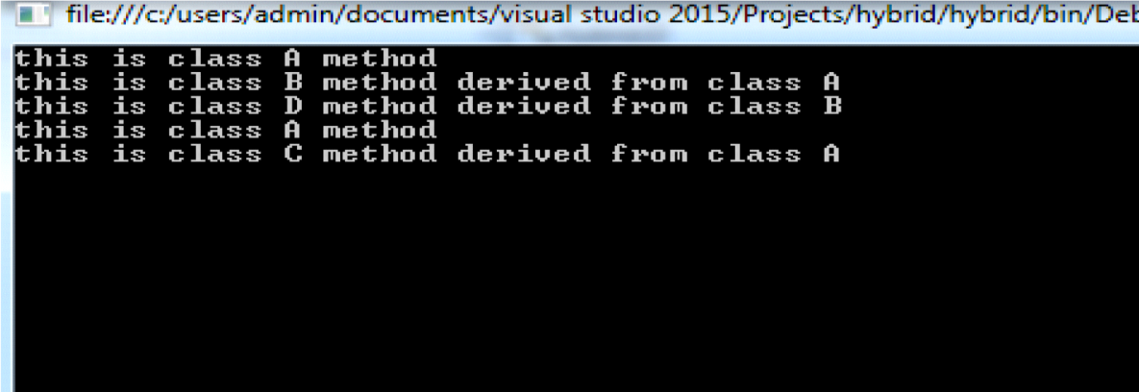

**iii.Constructor overloading**

**Source Code:**

using System;

using System.Collections.Generic;

using System.Linq;

using System.Text;

using System.Threading.Tasks;

namespace cons_overloading

{

class area

{

public area()

{

int r;

Console.WriteLine("enter r value");

r = int.Parse(Console.ReadLine());

double c = 3.142 * r * r;

Console.WriteLine("Area of circle=" + c);

}

public area(int a)

{

int s; s = a * a;

Console.WriteLine("Area of square=" + s);

}

public area(int l, int b)

{

int r;

r = l * b;

Console.WriteLine("Area of reactangle=" + r);

}

static void Main(string[] args)

{

area a1 = new area();

area p = new area(5);

area a = new area(3, 4);

Console.ReadKey();

}

}

}

**Output:**

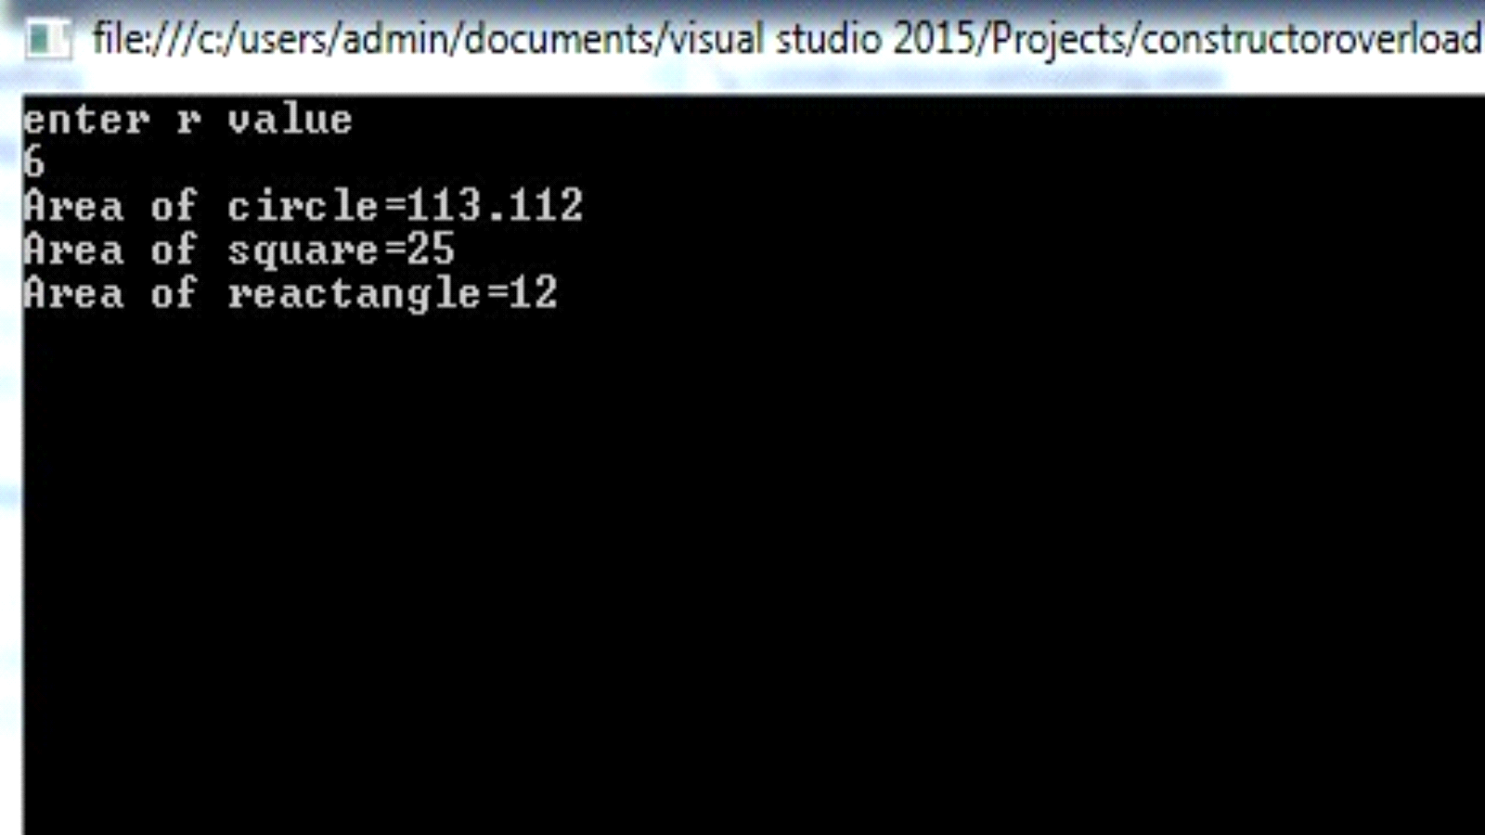

**iv.Interfaces**

**Source Code:**

using System;

using System.Collections.Generic;

using System.Linq;

using System.Text;

using System.Threading.Tasks;

namespace interface1

{

class Program

{

static void Main(string[] args)

{

C c1 = new C();

c1.disp1();

c1.disp2();

Console.ReadKey();

}

}

interface A

{

void disp1(); }

class C : A

{

public void disp2()

{

Console.WriteLine("this is class c ");

}

public void disp1()

{

Console.WriteLine("this is interface ");

}}}

**Output:**

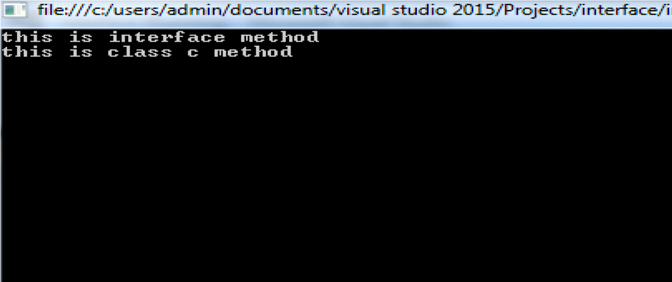

**c.Create simple application to demonstrate use of following concepts**

**i .Using Delegates and events**

**Source Code:**

using System;

using System.Collections.Generic;

using System.Linq;

using System.Text;

using System.Threading.Tasks;

namespace delegat

{

public delegate void add_num(int a, int b);

public delegate string say(string n);

class Program

{

public void add_num(int a, int b)

{

Console.WriteLine("Addition =" + (a + b));

}

public string say(string n)

{

return "Hello" + n;

}

static void Main(string[] args)

{

Program p = new Program();

add_num a = new add_num(p.add_num);

a(5, 5);

say s = new say(p.say);

Console.WriteLine(s("sandeep"));

Console.ReadKey();

}}}

**Output:**

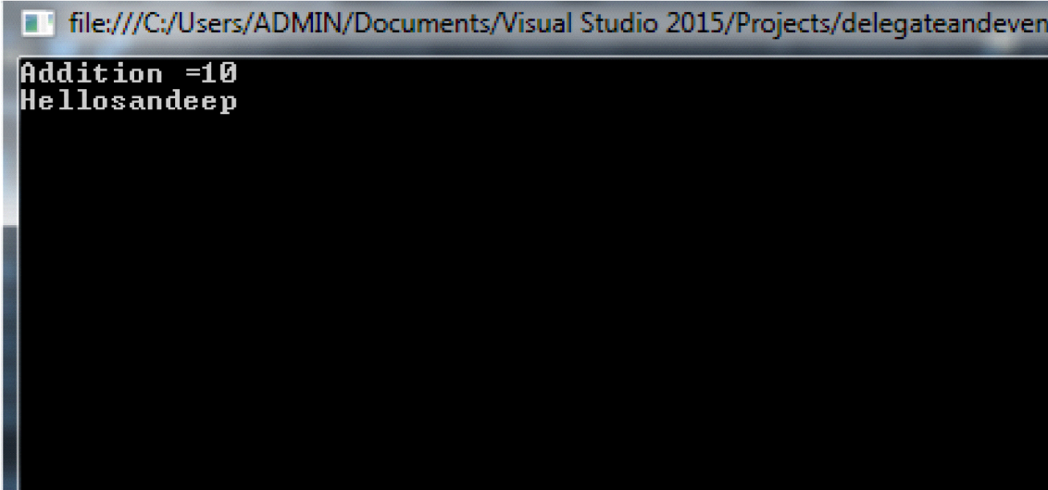

**ii.Exception handling**

**Source Code:**

using System;

using System.Collections.Generic;

using System.Linq;

using System.Text;

using System.Threading.Tasks;

namespace ex_handling

{

class Program

{

int result;

public void division(int a, int b)

{

try

{

result = a / b;

}

catch(DivideByZeroException e)

{

Console.WriteLine("exception occur:{0}", e);

}

finally

{

Console.WriteLine("Result:{0}", result);

}

}

static void Main(string[] args)

{

Program p = new Program();

p.division(7, 0);

Console.ReadKey();

}}}

**Output:** 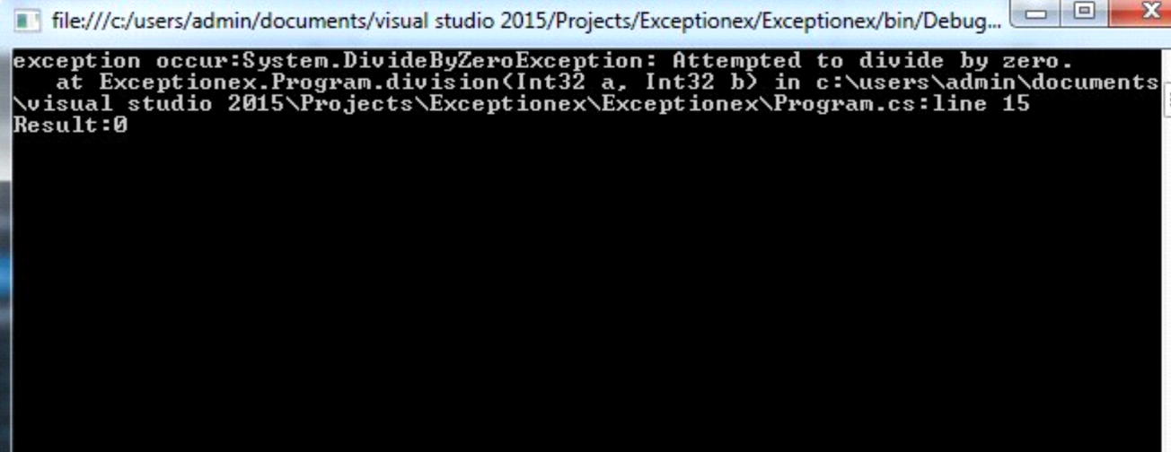

**Practical No.3(a)**

**Problem Statements : Create a simple web page with various server controls to demonstrate setting and use of their properties (Examples : AutoPostBack).**

**Source Code** :

**Servercontrol.aspx :**

<%@ Page Language="C#" AutoEventWireup="true" CodeBehind="servercontrol.aspx.cs" Inherits="prect_3_a_.servercontrol" %>

<!DOCTYPE html PUBLIC "-//W3C//DTD XHTML 1.0 Transitional//EN" "http://www.w3.org/TR/xhtml1/DTD/xhtml1-transitional.dtd">

<html xmlns="http://www.w3.org/1999/xhtml">

<head runat="server">

<title></title>

</head>

<body>

<form id="form1" runat="server">

<div>

<center><h1>Example of AutoPostBack</h1></center>

<asp:Label ID="abl_fn" runat="server" Text="First name"></asp:Label>

&nbsp;&nbsp;&nbsp;

<asp:TextBox ID="txt_fn" runat="server"></asp:TextBox>

<br />

<br />

<asp:Label ID="lbl_ln" runat="server" Text="Last name"></asp:Label>

&nbsp;&nbsp;&nbsp;

<asp:TextBox ID="txt_ln" runat="server"></asp:TextBox>

<br />

<br />

<asp:Label ID="lbl_add" runat="server" Text="Address"></asp:Label>

&nbsp;&nbsp;&nbsp;&nbsp;&nbsp;

<asp:TextBox ID="txt_add" runat="server" TextMode="MultiLine"></asp:TextBox>

<br />

<br />

<asp:Label ID="lbl_gen" runat="server" Text="Select your gender"></asp:Label>

&nbsp;&nbsp;&nbsp;

<asp:RadioButton ID="r_male" runat="server" Text="Male" GroupName="Gen" />

&nbsp;<asp:RadioButton ID="r_female" runat="server" Text="Female" GroupName="Gen" />

<br />

<br />

<asp:Label ID="Label1" runat="server" Text="select your subject name"></asp:Label>

<br />

<br />

<asp:CheckBox ID="CheckBox1" runat="server" Text="Physics"

oncheckedchanged="CheckBox1_CheckedChanged" />

&nbsp;&nbsp;&nbsp;

<asp:CheckBox ID="CheckBox2" runat="server" Text="Chemistry"

oncheckedchanged="CheckBox2_CheckedChanged" />

&nbsp;&nbsp;

<asp:CheckBox ID="CheckBox3" runat="server" Text="Biology"

oncheckedchanged="CheckBox3_CheckedChanged" />

&nbsp;&nbsp;

<asp:CheckBox ID="CheckBox4" runat="server" Text="Math"

oncheckedchanged="CheckBox4_CheckedChanged" />

<br />

<br />

<asp:Label ID="Label2" runat="server" Text="select your state"></asp:Label>

<br />

<asp:DropDownList ID="DropDownList1" runat="server" **AutoPostBack="true"**

onselectedindexchanged="DropDownList1_SelectedIndexChanged">

<asp:ListItem>Maharashtra</asp:ListItem>

<asp:ListItem>uttapredesh</asp:ListItem>

<asp:ListItem>madyapradesh</asp:ListItem>

<asp:ListItem>uttrakhand</asp:ListItem>

<asp:ListItem>tamilnadu</asp:ListItem>

<asp:ListItem>bihar</asp:ListItem>

<asp:ListItem>meghalay</asp:ListItem>

<asp:ListItem>sikkim</asp:ListItem>

<asp:ListItem>andhrapredesh</asp:ListItem>

<asp:ListItem>tripura</asp:ListItem>

<asp:ListItem>mijoram</asp:ListItem>

<asp:ListItem>keral</asp:ListItem>

</asp:DropDownList>

<br />

<br />

<asp:Label ID="Label3" runat="server" Text="select your language"></asp:Label>

<br />

<asp:ListBox ID="ListBox1" runat="server"

onselectedindexchanged="ListBox1_SelectedIndexChanged">

<asp:ListItem>Hindi</asp:ListItem>

<asp:ListItem>English</asp:ListItem>

<asp:ListItem>Marathi</asp:ListItem>

<asp:ListItem>Gujrati</asp:ListItem>

<asp:ListItem>Assamese</asp:ListItem>

<asp:ListItem>Dorgi</asp:ListItem>

<asp:ListItem>Kannada</asp:ListItem>

<asp:ListItem>kashmiri</asp:ListItem>

<asp:ListItem>Nepali</asp:ListItem>

<asp:ListItem>Telgu</asp:ListItem>

<asp:ListItem>Sindhi</asp:ListItem>

<asp:ListItem>Sanskriti</asp:ListItem>

</asp:ListBox>

<br />

<br />

&nbsp;&nbsp;&nbsp;&nbsp;&nbsp;&nbsp;&nbsp;&nbsp;&nbsp;&nbsp;&nbsp;&nbsp;&nbsp;&nbsp;&nbsp;&nbsp;&nbsp;&nbsp;&nbsp;&nbsp;&nbsp;&nbsp;&nbsp;&nbsp;&nbsp;&nbsp;&nbsp;&nbsp;

<asp:Button ID="Button1" runat="server" onclick="Button1_Click" Text="Button"

Width="84px" />

<br />

<br />

<asp:Label ID="Label4" runat="server" Text="Label"></asp:Label>

<br />

<asp:Label ID="Label5" runat="server" Text="Label"></asp:Label>

<br />

<asp:Label ID="Label6" runat="server" Text="Label"></asp:Label>

<br />

<asp:Label ID="Label7" runat="server" Text="Label"></asp:Label>

<br />

<asp:Label ID="Label8" runat="server" Text="Label"></asp:Label>

<br />

<asp:Label ID="Label9" runat="server" Text="Label"></asp:Label>

<br />

<asp:Label ID="Label10" runat="server" Text="Label"></asp:Label>

<br />

<asp:Label ID="Label11" runat="server" Text="Label"></asp:Label>

<br />

<asp:Label ID="Label12" runat="server" Text="Label"></asp:Label>

<br />

<asp:Label ID="Label13" runat="server" Text="Label"></asp:Label>

<br />

<br />

<br />

</div>

</form>

</body>

</html>

**Servercontrol.aspx.cs :**

using System;

using System.Collections.Generic;

using System.Linq;

using System.Web;

using System.Web.UI;

using System.Web.UI.WebControls;

namespace prect_3_a_

{

public partial class servercontrol : System.Web.UI.Page

{

protected void Page_Load(object sender, EventArgs e)

{

}

protected void Button1_Click(object sender, EventArgs e)

{

Label4.Text = "Your first name=" + txt_fn.Text;

Label5.Text = "Your last name=" + txt_ln.Text;

Label6.Text = "Address is=" + txt_add.Text;

if (r_male.Checked)

{

Label7.Text = "Your gender is=" + r_male.Text;

}

else

{

Label7.Text = "Your gender is=" + r_female.Text;

}

}

protected void CheckBox1_CheckedChanged(object sender, EventArgs e)

{

Label8.Text = "1) subject name =" + CheckBox1.Text;

}

protected void CheckBox2_CheckedChanged(object sender, EventArgs e)

{

Label9.Text = "2) subject name =" + CheckBox2.Text;

}

protected void CheckBox3_CheckedChanged(object sender, EventArgs e)

{

Label10.Text = "3) subject name =" + CheckBox3.Text;

}

protected void CheckBox4_CheckedChanged(object sender, EventArgs e)

{

Label11.Text = "4) subject name i=" + CheckBox4.Text;

}

protected void DropDownList1_SelectedIndexChanged(object sender, EventArgs e)

{

Label12.Text = "Your state name is=" + DropDownList1.SelectedItem;

}

protected void ListBox1_SelectedIndexChanged(object sender, EventArgs e)

{

Label13.Text = "your language=" + ListBox1.SelectedItem.Value;

}

}

}

**Design** :

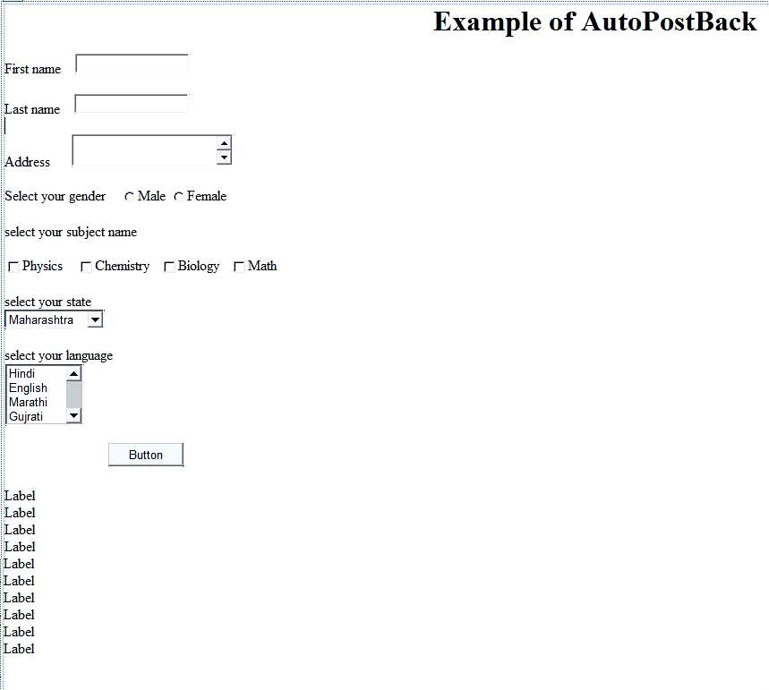

**Output** :

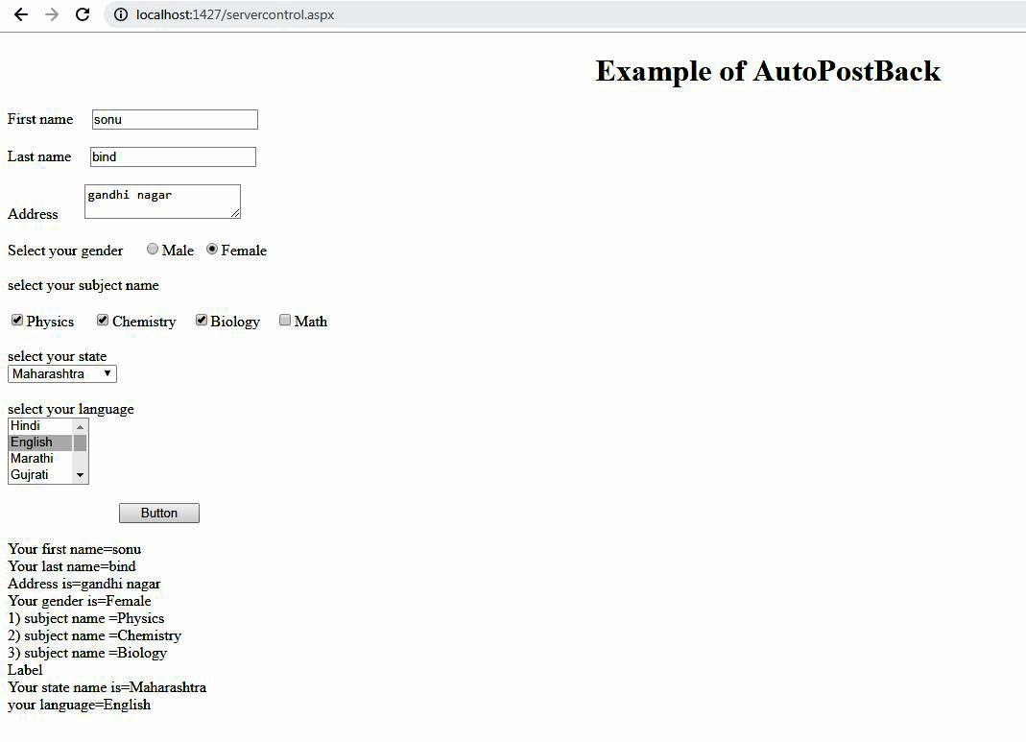

**Practical No.3(b)**

**Problem statements :** demonstrate the use of Calender control to perform following operations.

1. Display messages in a calender control
2. Display vacation in a calender control
3. Selected day in a calender control using style
4. Difference between two calender dates

**Calender Control** :

**Source code** :

**calenderoperation.aspx** :

<%@ Page Language="C#" AutoEventWireup="true" CodeBehind="calenderoperation.aspx.cs" Inherits="prect3_b_.calenderoperation" %>

<!DOCTYPE html PUBLIC "-//W3C//DTD XHTML 1.0 Transitional//EN" "http://www.w3.org/TR/xhtml1/DTD/xhtml1-transitional.dtd">

<html xmlns="http://www.w3.org/1999/xhtml">

<head runat="server">

<title></title>

</head>

<body>

<form id="form1" runat="server">

<div>

<asp:Calendar ID="Calendar1" runat="server" BackColor="#FFFFCC"

BorderColor="#FFCC66" BorderWidth="1px" Caption="TYIT Calender"

Font-Names="Verdana" Font-Size="8pt" ForeColor="#663399" Height="200px"

NextPrevFormat="ShortMonth" ondayrender="Calendar1_DayRender"

onselectionchanged="Calendar1_SelectionChanged" ShowGridLines="True"

Width="220px">

<DayHeaderStyle BackColor="#FFCC66" Font-Bold="True" Height="1px" />

<NextPrevStyle Font-Size="9pt" ForeColor="#FFFFCC" />

<OtherMonthDayStyle ForeColor="#CC9966" />

<SelectedDayStyle BackColor="#CCCCFF" Font-Bold="True" />

<SelectorStyle BackColor="#FFCC66" />

<TitleStyle BackColor="#990000" Font-Bold="True" Font-Size="9pt"

ForeColor="#FFFFCC" />

<TodayDayStyle BackColor="#FFCC66" ForeColor="White" />

</asp:Calendar>

<br />

<asp:Label ID="Label1" runat="server" Text="Label"></asp:Label>

<br />

<br />

<asp:Label ID="Label2" runat="server" Text="Label"></asp:Label>

<br />

<br />

<asp:Label ID="Label3" runat="server" Text="Label"></asp:Label>

<br />

<br />

&nbsp;&nbsp;&nbsp;&nbsp;&nbsp;&nbsp;&nbsp;&nbsp;&nbsp;&nbsp;&nbsp;

<asp:Button ID="Button1" runat="server" onclick="Button1_Click"

Text="check vacation" />

&nbsp;&nbsp;&nbsp;&nbsp;&nbsp;

</div>

</form>

</body>

</html>

**calenderoperation.aspx.cs**  :

using System;

using System.Collections.Generic;

using System.Linq;

using System.Web;

using System.Web.UI;

using System.Web.UI.WebControls;

namespace prect3_b_

{

public partial class calenderoperation : System.Web.UI.Page

{

protected void Page_Load(object sender, EventArgs e)

{

}

protected void Calendar1_SelectionChanged(object sender, EventArgs e)

{

Label1.Text = "Your selected dates : " + Calendar1.SelectedDate.ToShortDateString();

Label2.Text = "Your selected dates : " + Calendar1.SelectedDate.ToLongDateString();

}

protected void Button1_Click(object sender, EventArgs e)

{

TimeSpan d = new DateTime(2018, 9, 13) - DateTime.Now;

Label3.Text = "Ganpati Vacation is after : " + d.Days.ToString();

}

protected void Calendar1_DayRender(object sender, DayRenderEventArgs e)

{

if (e.Day.Date.Day == 5 && e.Day.Date.Month == 9)

e.Cell.Controls.Add(new LiteralControl("<br/>Teacher's day"));

if (e.Day.Date.Day == 18 && e.Day.Date.Month == 9)

e.Cell.Controls.Add(new LiteralControl("<br/>Holiday"));

if (e.Day.IsOtherMonth)

{

e.Day.IsSelectable = false;

//e.Cell.BackColor=System.drawing.Color.Red;

e.Cell.Controls.Clear();

}

if (e.Day.Date >= new DateTime(2018, 9, 13) && (e.Day.Date <= new DateTime(2018, 9, 18)))

{

e.Cell.BackColor = System.Drawing.Color.Red;

e.Cell.BorderColor = System.Drawing.Color.Green;

e.Cell.BorderWidth = new Unit(3);

}

}

protected void Button2_Click(object sender, EventArgs e)

{

}

}

}

**Design** :

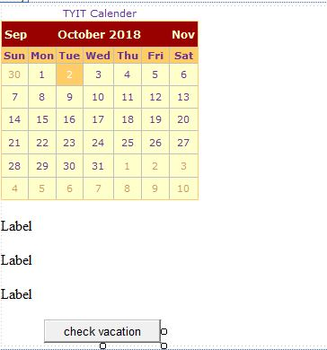

**Output** :

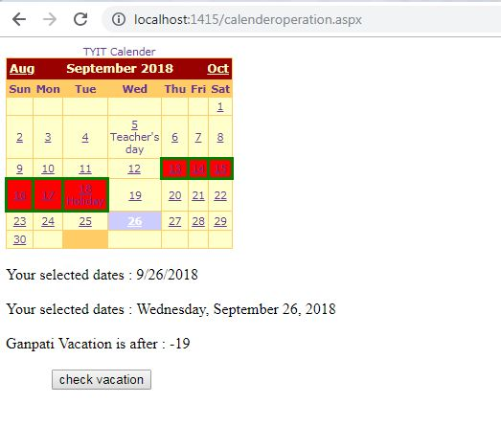

**Practical No.3(c)**

**Problem Statement** :-Demonstrate the use of TreeView control perform following operations.

1. Treeview control and datalist b) Treeview operations

**Treeview control :**

**Xml File :**

**stdetail.xml**

<?xml version="1.0" encoding="utf-8" ?>

<studentdetail>

<student>

<sid>1</sid>

<sname>sonu</sname>

<sclass>TYIT</sclass>

</student>

<student>

<sid>2</sid>

<sname>shruti</sname>

<sclass>TYCS</sclass>

</student>

<student>

<sid>1</sid>

<sname>seema</sname>

<sclass>TYIT</sclass>

</student>

<student>

<sid>1</sid>

<sname>sweta</sname>

<sclass>TYCS</sclass>

</student>

</studentdetail>

**Source code** :

**Default.aspx :**

<%@ Page Language="C#" AutoEventWireup="true" CodeBehind="Default.aspx.cs" Inherits="prect_3_c_.Default" %>

<!DOCTYPE html PUBLIC "-//W3C//DTD XHTML 1.0 Transitional//EN" "http://www.w3.org/TR/xhtml1/DTD/xhtml1-transitional.dtd">

<html xmlns="http://www.w3.org/1999/xhtml">

<head runat="server">

<title></title>

</head>

<body>

<form id="form1" runat="server">

<div>

<asp:TreeView ID="TreeView1" runat="server" ForeColor="#FF3300">

<HoverNodeStyle Font-Underline="True" />

<Nodes>

<asp:TreeNode Text="ASP.NET Practs " Value="New Node">

<asp:TreeNode Text="Calender Control" Value="RED"

NavigateUrl="~/cal.aspx"></asp:TreeNode>

<asp:TreeNode Text="Construtor OVerloading" Value="GREEN"

NavigateUrl="~/consover.aspx"></asp:TreeNode>

<asp:TreeNode Text="Inheritence" Value="BLUE"

NavigateUrl="~/singleInh.aspx"></asp:TreeNode>

<asp:TreeNode Text="Class properties" Value="Class properties"

NavigateUrl="~/clcProp.aspx"></asp:TreeNode>

</asp:TreeNode>

</Nodes>

</asp:TreeView>

<br/>

Fetch Datalist Using Xml data : </div>

<asp:DataList ID="DataList1" runat="server">

<ItemTemplate>

<table class="table" border="1">

<tr>

<td>Roll Num:<%# Eval("sid") %><br/>

Name:<%# Eval("sname") %><br/>

Class:<%# Eval("sclass") %>

</td>

</tr>

<table>

</ItemTemplate>

</asp:DataList>

</form>

</body>

</html>

**Default.aspx.cs** :

using System;

using System.Collections.Generic;

using System.Linq;

using System.Web;

using System.Web.UI;

using System.Web.UI.WebControls;

using System.Data;

namespace prect_3_c_

{

public partial class Default : System.Web.UI.Page

{

protected void Page_Load(object sender, EventArgs e)

{

if (!IsPostBack)

{

BindData();

}

}

protected void BindData()

{

DataSet ds = new DataSet();

ds.ReadXml(Server.MapPath("Stdetail.xml"));

if (ds != null && ds.HasChanges())

{

DataList1.DataSource = ds;

DataList1.DataBind();

}

else

{

DataList1.DataBind();

}

}

}

**Design :**

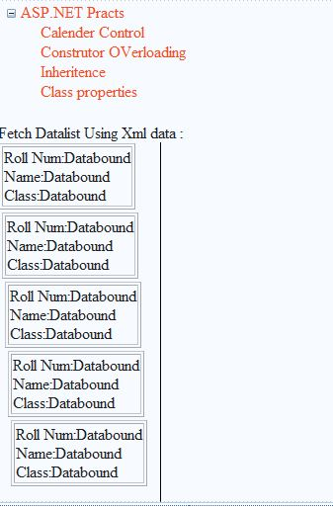

**Output :**

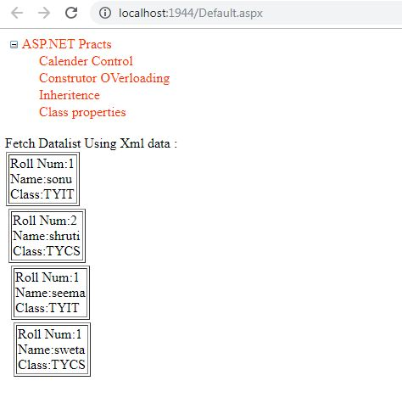

**Practical No.4(a)**

**Problem statements :** create a Registration form to demonstrate use of various Validation controls.

**Validation control** :

**Source code** :

**validationcontrol.aspx :**

<%@ Page Language="C#" AutoEventWireup="true" CodeBehind="validationcontrol.aspx.cs" Inherits="prect_4_a_.validationcontrol" %>

<!DOCTYPE html PUBLIC "-//W3C//DTD XHTML 1.0 Transitional//EN" "http://www.w3.org/TR/xhtml1/DTD/xhtml1-transitional.dtd">

<html xmlns="http://www.w3.org/1999/xhtml">

<head runat="server">

<title></title>

</head>

<body>

<form id="form1" runat="server">

<div>

<asp:Label ID="lbl_n" runat="server" Text="Name"></asp:Label>

&nbsp;&nbsp;&nbsp;&nbsp;&nbsp;&nbsp;&nbsp;&nbsp;&nbsp;

<asp:TextBox ID="txt_n" runat="server"></asp:TextBox>

<asp:RequiredFieldValidator ID="RequiredFieldValidator1" runat="server"

ControlToValidate="txt_n" ErrorMessage="please enter first name"

ForeColor="Red"></asp:RequiredFieldValidator>

<br />

<br />

<asp:Label ID="lbl_id" runat="server" Text="userid"></asp:Label>

&nbsp;&nbsp;&nbsp;&nbsp;&nbsp;&nbsp;&nbsp;&nbsp;&nbsp;&nbsp;

<asp:TextBox ID="txt_id" runat="server"></asp:TextBox>

<asp:RequiredFieldValidator ID="RequiredFieldValidator2" runat="server"

ControlToValidate="txt_id" ErrorMessage="please enter userid"

ForeColor="#FF5050"></asp:RequiredFieldValidator>

<br />

<br />

<asp:Label ID="lbl_age" runat="server" Text="Age"></asp:Label>

&nbsp;&nbsp;&nbsp;&nbsp;&nbsp;&nbsp;&nbsp;&nbsp;&nbsp;&nbsp;&nbsp;&nbsp;&nbsp;

<asp:TextBox ID="txt_age" runat="server"></asp:TextBox>

<asp:RequiredFieldValidator ID="RequiredFieldValidator3" runat="server"

ControlToValidate="txt_age" Display="Dynamic"

ErrorMessage="please enter your age" ForeColor="#FF5050"></asp:RequiredFieldValidator>

&nbsp;

<asp:RangeValidator ID="RangeValidator1" runat="server"

ControlToValidate="txt_age" Display="Dynamic"

ErrorMessage="Age must be between 15 to 30" ForeColor="#FF3300"

MaximumValue="30" MinimumValue="15" Type="Integer"></asp:RangeValidator>

<br />

<br />

<asp:Label ID="lbl_pass" runat="server" Text="password"></asp:Label>

&nbsp;&nbsp;&nbsp;&nbsp;&nbsp;&nbsp;&nbsp;&nbsp;

<asp:TextBox ID="txt_pass" runat="server" Height="22px" Width="130px"></asp:TextBox>

<asp:RequiredFieldValidator ID="RequiredFieldValidator4" runat="server"

ControlToValidate="txt_pass" Display="Dynamic"

ErrorMessage="please enter the password" ForeColor="#FF6600"></asp:RequiredFieldValidator>

&nbsp;

<br />

<br />

<asp:Label ID="lbl_cnfpass" runat="server" Text="confirm password"></asp:Label>

&nbsp;&nbsp;&nbsp;&nbsp;

<asp:TextBox ID="txt_cnfpass" runat="server"></asp:TextBox>

<asp:RequiredFieldValidator ID="RequiredFieldValidator5" runat="server"

ControlToValidate="txt_cnfpass" Display="Dynamic"

ErrorMessage="please enter the confirm password" ForeColor="#FF6600"></asp:RequiredFieldValidator>

&nbsp;&nbsp;

<asp:CompareValidator ID="CompareValidator1" runat="server"

ControlToCompare="txt_pass" ControlToValidate="txt_cnfpass" Display="Dynamic"

ErrorMessage="password not match" ForeColor="Red"></asp:CompareValidator>

<br />

<br />

<asp:Label ID="lbl_mob" runat="server" Text="Mobile number"></asp:Label>

&nbsp;&nbsp;&nbsp;&nbsp;

<asp:TextBox ID="txt_mob" runat="server" Height="22px"></asp:TextBox>

<asp:RequiredFieldValidator ID="RequiredFieldValidator6" runat="server"

ControlToValidate="txt_mob" Display="Dynamic"

ErrorMessage="please enter mobile number" ForeColor="#FF6600"></asp:RequiredFieldValidator>

&nbsp;

<asp:RegularExpressionValidator ID="RegularExpressionValidator2" runat="server"

ControlToValidate="txt_mob" Display="Dynamic"

ErrorMessage="Enter 10 digits numbers only" ForeColor="#FF5050"></asp:RegularExpressionValidator>

<br />

<br />

<br />

<asp:Label ID="lbl_em" runat="server" Text="EmailId"></asp:Label>

&nbsp;&nbsp;&nbsp;&nbsp;&nbsp;&nbsp;&nbsp;&nbsp;&nbsp;&nbsp;&nbsp;&nbsp;&nbsp;&nbsp;

<asp:TextBox ID="txt_em" runat="server"></asp:TextBox>

<asp:RequiredFieldValidator ID="RequiredFieldValidator7" runat="server"

ControlToValidate="txt_em" Display="Dynamic"

ErrorMessage="please enter the EmailId" ForeColor="Red"></asp:RequiredFieldValidator>

&nbsp;

<asp:RegularExpressionValidator ID="RegularExpressionValidator1" runat="server"

ControlToValidate="txt_em" Display="Dynamic" ErrorMessage="Invalid email"

ForeColor="#FF5050"></asp:RegularExpressionValidator>

<br />

<br />

<br />

&nbsp;&nbsp;&nbsp;&nbsp;&nbsp;&nbsp;&nbsp;&nbsp;&nbsp;&nbsp;&nbsp;&nbsp;&nbsp;&nbsp;&nbsp;&nbsp;

<asp:Button ID="Button1" runat="server" onclick="Button1_Click" Text="Submit" />

&nbsp;<br />

<br />

<asp:Label ID="Label1" runat="server" Text="Label"></asp:Label>

<br />

<br />

<asp:Label ID="Label2" runat="server" Text="Label"></asp:Label>

<br />

<br />

<asp:Label ID="Label3" runat="server" Text="Label"></asp:Label>

<br />

<br />

<asp:Label ID="Label4" runat="server" Text="Label"></asp:Label>

<br />

<br />

<asp:Label ID="Label5" runat="server" Text="Label"></asp:Label>

<br />

<br />

<asp:Label ID="Label6" runat="server" Text="Label"></asp:Label>

<br />

<br />

<asp:Label ID="Label7" runat="server" Text="Label"></asp:Label>

<br />

<br />

<br />

<br />

<br />

<br />

<br />

<br />

<br />

<br />

<br />

<br />

</div>

</form>

</body>

</html>

**validationcontrol.aspx.cs :**

using System;

using System.Collections.Generic;

using System.Linq;

using System.Web;

using System.Web.UI;

using System.Web.UI.WebControls;

namespace prect_4_a_

{

public partial class validationcontrol : System.Web.UI.Page

{

protected void Page_Load(object sender, EventArgs e)

{

}

protected void Button1_Click(object sender, EventArgs e)

{

Label1.Text = "Your name is=" + txt_n.Text;

Label2.Text = "Your userid is=" + txt_id.Text;

Label3.Text = "Your age is=" + txt_age.Text;

Label4.Text = "Your password is=" + txt_pass.Text;

Label5.Text = "Your confirm password is=" + txt_cnfpass.Text;

Label6.Text = "Your mobile number is=" + txt_mob.Text;

Label7.Text = "Your emailid is=" + txt_em.Text;

if (this.IsValid)

{

Label1.Text = "Data Saved";

Label1.ForeColor = System.Drawing.Color.Green;

}

else

{

Label1.Text = "Data not Saved";

Label1.ForeColor = System.Drawing.Color.Red;

}

}

}

}

**Design** :

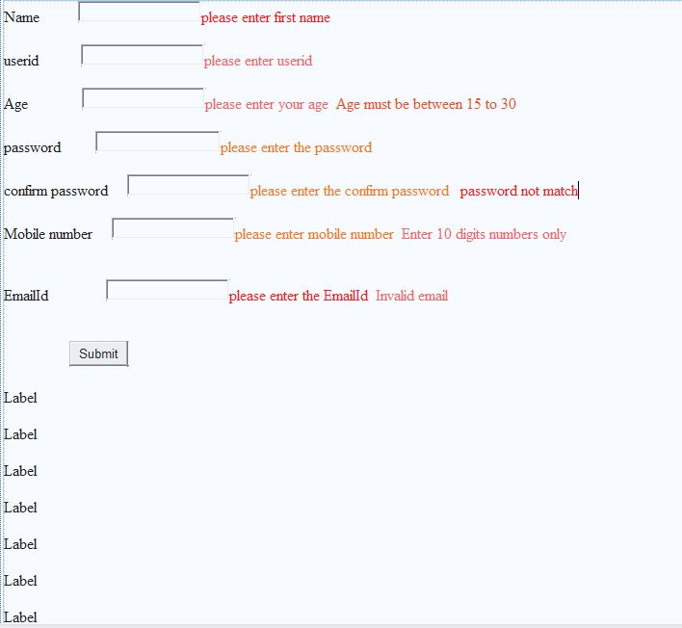

**Output :**

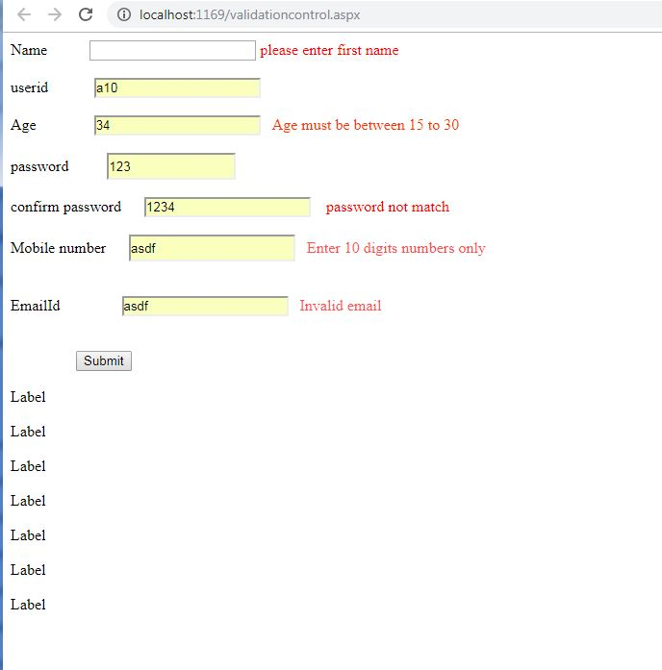

**Practical No.4(b)**

**Problem Statement :** create WebForm to demonstrate use of Adrotator controls.

**Adrotator Control :**

**XmL file:**

**XMLFile.xml:**

<?xml version="1.0" encoding="utf-8" ?>

<Advertisements>

<Ad>

<ImageUrl>http://localhost:2932/WebSite4/Images/Fi0D7FGJ_400x400.jpg</ImageUrl>

<NavigateUrl>http://google.com</NavigateUrl>

<Alternate-Text>please visit http://www.Google.com</Alternate-Text>

<Impressions>15</Impressions>

</Ad>

<Ad>

<ImageUrl>http://localhost:2932/WebSite4/Images/aQltRN9T.jpg</ImageUrl>

<NavigateUrl>http://Utube.com</NavigateUrl>

<Alternate-Text>please visit http://www.Utube.com</Alternate-Text>

<Impressions>15</Impressions>

</Ad>

<Ad>

<ImageUrl>http://localhost:2932/WebSite4/Images/fb_icon_325x325.png</ImageUrl>

<NavigateUrl>http://facebook.com</NavigateUrl>

<Alternate-Text>please visit http://www.facebook.com</Alternate-Text>

<Impressions>15</Impressions>

</Ad>

</Advertisements>

**Source code** :

**Default.aspx** :

<%@ Page Language="C#" AutoEventWireup="true" CodeFile="Default.aspx.cs" Inherits="_Default" %>

<!DOCTYPE html PUBLIC "-//W3C//DTD XHTML 1.0 Transitional//EN" "http://www.w3.org/TR/xhtml1/DTD/xhtml1-transitional.dtd">

<html xmlns="http://www.w3.org/1999/xhtml">

<head runat="server">

<title></title>

</head>

<body>

<form id="form1" runat="server">

<div>

<asp:AdRotator ID="AdRotator1" runat="server"

target="_blank" AdvertisementFile="~/XMLFile.xml"/>

</div>

</form>

</body>

</html>

**Design :**

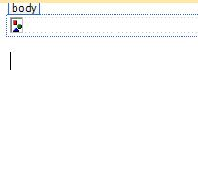

**Output :**

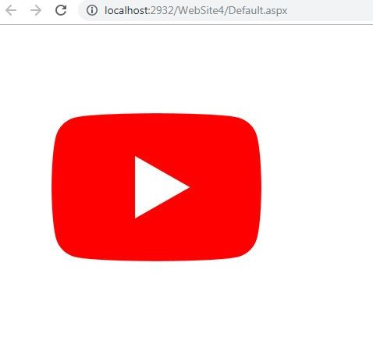

**Practical No.4(c)**

**Problem statements : -**Create WebForm to demonstrate use User Controls**.**

**UserControl :**

**Source Code :**

**WebUserControl.ascx :**

<%@ Control Language="C#" AutoEventWireup="true" CodeFile="WebUserControl.ascx.cs" Inherits="WebUserControl" %>

<asp:Label ID="Label1" runat="server" Text="first name : "></asp:Label>

&nbsp;

<asp:TextBox ID="TextBox1" runat="server"></asp:TextBox>

<br />

<br />

<br />

&nbsp;&nbsp;&nbsp;&nbsp;&nbsp;&nbsp;&nbsp;&nbsp;

<asp:Button ID="Button1" runat="server" onclick="Button1_Click" Text="Button" />

<p>

&nbsp;</p>

<p>

&nbsp;&nbsp;

</p>

**WebUserControl.ascx .cs :**

using System;

using System.Collections.Generic;

using System.Linq;

using System.Web;

using System.Web.UI;

using System.Web.UI.WebControls;

public partial class WebUserControl : System.Web.UI.UserControl

{

protected void Page_Load(object sender, EventArgs e)

{

}

protected void Button1_Click(object sender, EventArgs e)

{

Label1.Text = TextBox1.Text;

}

}

**Design……….. WebUsercontrol :**

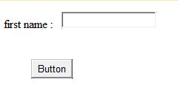

**Source Code :**

**Dafault.aspx :**

<%@ Page Language="C#" AutoEventWireup="true" CodeFile="Default.aspx.cs" Inherits="_Default" %>

**<%@ Register src="WebUserControl.ascx" tagname="WebUserControl" tagprefix="uc1" %>**

<!DOCTYPE html PUBLIC "-//W3C//DTD XHTML 1.0 Transitional//EN" "http://www.w3.org/TR/xhtml1/DTD/xhtml1-transitional.dtd">

<html xmlns="http://www.w3.org/1999/xhtml">

<head runat="server">

<title></title>

</head>

<body>

<form id="form1" runat="server">

**<uc1:WebUserControl ID="WebUserControl1" runat="server"** />

<div>

</div>

</form>

</body>

</html>

**Design……….Dafault.aspx :**



**Output :**

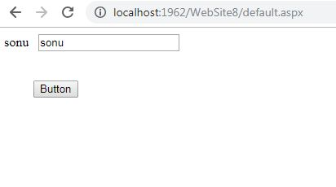

**Practical No.5(a)**

**Problem Statements :-**Create Web Form to demonstrate use of Website Navigation controls and Site Map

**SiteMap** :

**Web.sitemap** :

<?xml version="1.0" encoding="utf-8" ?>

<siteMap xmlns="http://schemas.microsoft.com/AspNet/SiteMap-File-1.0" >

<siteMapNode url="Default2.aspx" title="Home" description="">

<siteMapNode url="Default3.aspx" title="Second" description="" />

<siteMapNode url="Default4.aspx" title="Third" description="" />

</siteMapNode>

</siteMap>

**Source Code** :

**Default2.aspx** :

<%@ Page Language="C#" AutoEventWireup="true" CodeBehind="Default2.aspx.cs" Inherits="sitemappath.Default2" %>

<!DOCTYPE html PUBLIC "-//W3C//DTD XHTML 1.0 Transitional//EN" "http://www.w3.org/TR/xhtml1/DTD/xhtml1-transitional.dtd">

<html xmlns="http://www.w3.org/1999/xhtml">

<head runat="server">

<title></title>

</head>

<body>

<form id="form1" runat="server">

<div>

<asp:SiteMapPath ID="SiteMapPath1" runat="server" EnableTheming="False">

</asp:SiteMapPath>

</div>

<asp:Menu ID="Menu1" runat="server" DataSourceID="SiteMapDataSource1">

</asp:Menu>

<asp:SiteMapDataSource ID="SiteMapDataSource1" runat="server" />

</form>

</body>

</html>

**Default3.aspx** :

<%@ Page Language="C#" AutoEventWireup="true" CodeBehind="Default3.aspx.cs" Inherits="sitemappath.Default3" %>

<!DOCTYPE html PUBLIC "-//W3C//DTD XHTML 1.0 Transitional//EN" "http://www.w3.org/TR/xhtml1/DTD/xhtml1-transitional.dtd">

<html xmlns="http://www.w3.org/1999/xhtml">

<head runat="server">

<title></title>

</head>

<body>

<form id="form1" runat="server">

<div>

<asp:SiteMapPath ID="SiteMapPath1" runat="server" EnableTheming="False">

</asp:SiteMapPath>

<br/>Welcome to online store

</div>

</form>

</body>

</html>

**Default4.aspx** :

<%@ Page Language="C#" AutoEventWireup="true" CodeBehind="Default4.aspx.cs" Inherits="sitemappath.Default4" %>

<!DOCTYPE html PUBLIC "-//W3C//DTD XHTML 1.0 Transitional//EN" "http://www.w3.org/TR/xhtml1/DTD/xhtml1-transitional.dtd">

<html xmlns="http://www.w3.org/1999/xhtml">

<head runat="server">

<title></title>

</head>

<body>

<form id="form1" runat="server">

<div>

<asp:SiteMapPath ID="SiteMapPath1" runat="server">

</asp:SiteMapPath>

<br/>

Hi welcome to Online shopping :Mobile

</div>

</form>

</body>

</html>

**Design ……..1)Default2.aspx 2)Default3.aspx 3) Default4.aspx**

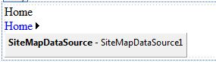

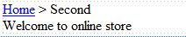

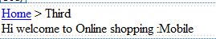

**Output :**

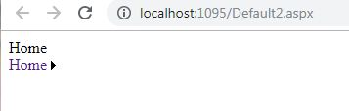

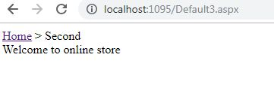

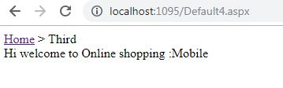

**Practical No.5(b)**

**Problem statements :-**create a web application to demonstrate use of Master Page with applying styles and Themes for page beatification.

**Stylesheet.css** :

body

{

background-color:Yellow;

font-family:Cambria;

font-size:18px;

}

**MasterPage.master** :

<%@ Master Language="C#" AutoEventWireup="true" CodeFile="MasterPage.master.cs" Inherits="MasterPage" %>

<!DOCTYPE html PUBLIC "-//W3C//DTD XHTML 1.0 Transitional//EN" "http://www.w3.org/TR/xhtml1/DTD/xhtml1-transitional.dtd">

<html xmlns="http://www.w3.org/1999/xhtml">

<head runat="server">

<title></title>

<link href="StyleSheet.css" rel="stylesheet" type="text/css" />

<asp:ContentPlaceHolder id="head" runat="server">

</asp:ContentPlaceHolder>

</head>

<body>

<form id="form1" runat="server">

<div>

<asp:ContentPlaceHolder id="ContentPlaceHolder1" runat="server">

</asp:ContentPlaceHolder>

</div>

<asp:ContentPlaceHolder ID="ContentPlaceHolder2" runat="server">

</asp:ContentPlaceHolder>

</form>

</body>

</html>

**Source Code** :

**Default.aspx** :

<%@ Page **Theme="SkinFile"** Title="" Language="C#" MasterPageFile="~/MasterPage.master" AutoEventWireup="true" CodeFile="Default.aspx.cs" Inherits="_Default" %>

<asp:Content ID="Content1" ContentPlaceHolderID="head" Runat="Server">

</asp:Content>

<asp:Content ID="Content2" ContentPlaceHolderID="ContentPlaceHolder1" Runat="Server">

<asp:Label ID="Label1" runat="server" Text="AWP"></asp:Label><br/>

</asp:Content>

<asp:Content ID="Content3" ContentPlaceHolderID="ContentPlaceHolder2" Runat="Server">

<asp:Label ID="Label2" runat="server" Text="Java"></asp:Label><br/>

<asp:Label ID="Label3" runat="server" Text="IOT"></asp:Label><br/>

<asp:Button ID="Button1" runat="server" Text="Click" onclick="Button1_Click1" />

</asp:Content>

**Default.aspx.cs :**

using System;

using System.Collections.Generic;

using System.Linq;

using System.Web;

using System.Web.UI;

using System.Web.UI.WebControls;

public partial class _Default : System.Web.UI.Page

{

protected void Page_Load(object sender, EventArgs e)

{

}

protected void Button1_Click1(object sender, EventArgs e)

{

Label3.Text = "student : sonu";

}

}

**SKINfile :**

**SkinFile.skin :**

<%--

Default skin template. The following skins are provided as examples only.

1. Named control skin. The SkinId should be uniquely defined because

duplicate SkinId's per control type are not allowed in the same theme.

<asp:GridView runat="server" SkinId="gridviewSkin" BackColor="White" >

<AlternatingRowStyle BackColor="Blue" />

</asp:GridView>

2. Default skin. The SkinId is not defined. Only one default

control skin per control type is allowed in the same theme.

<asp:Image runat="server" ImageUrl="~/images/image1.jpg" />

--%>

<asp:Label runat="server" ForeColor="red" Font-Size="14px" Font-Name="Verdana"/>

<asp:Button runat="server" Borderstyle="Solid" Border-Style="double" Borderwidth="20px"/>

**Design 1)..Masterpage….2) default.aspx**

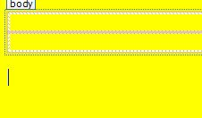

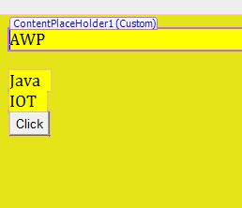

**Output :**

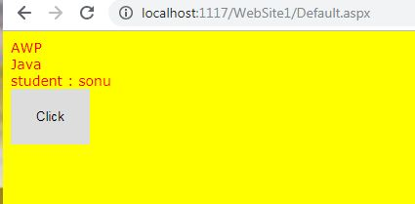

**Practical No.5(c)**

**Problem statements :-** create a web application to demonstrate various states of ASP.NET Pages.

**1)view state** :

**Source code** :

**viewstate.aspx :**

<%@ Page Language="C#" AutoEventWireup="true" CodeFile="viewstate.aspx.cs" Inherits="viewstate" %>

<!DOCTYPE html PUBLIC "-//W3C//DTD XHTML 1.0 Transitional//EN" "http://www.w3.org/TR/xhtml1/DTD/xhtml1-transitional.dtd">

<html xmlns="http://www.w3.org/1999/xhtml">

<head runat="server">

<title></title>

</head>

<body>

<form id="form1" runat="server">

<div>

<asp:Label ID="Label1" runat="server" Text="View State Data : "></asp:Label>

<asp:Label ID="Label2" runat="server" Text="Label"></asp:Label>

<br />

<br />

&nbsp;&nbsp;&nbsp;&nbsp;&nbsp;&nbsp;

<asp:Button ID="Button1" runat="server" onclick="Button1_Click"

Text="Get Data" />

</div>

</form>

</body>

</html>

**viewstate.aspx .cs:**

using System;

using System.Collections.Generic;

using System.Linq;

using System.Web;

using System.Web.UI;

using System.Web.UI.WebControls;

public partial class viewstate : System.Web.UI.Page

{

protected void Page_Load(object sender, EventArgs e)

{

if (!IsPostBack)

{

string str = "Vedshree Sambare";

if (ViewState["num"] == null)

{

ViewState["num"] = str;

}

}

}

protected void Button1_Click(object sender, EventArgs e)

{

Label2.Text = ViewState["num"].ToString();

}

}

**Design :**

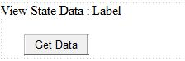

**Output:**

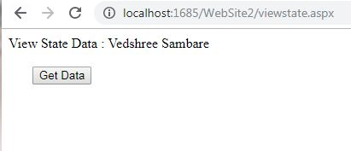

**2) QueryString :**

**Source code :**

**QueryString.aspx :**

<%@ Page Language="C#" AutoEventWireup="true" CodeFile="QueryString.aspx.cs" Inherits="QueryString" %>

<!DOCTYPE html PUBLIC "-//W3C//DTD XHTML 1.0 Transitional//EN" "http://www.w3.org/TR/xhtml1/DTD/xhtml1-transitional.dtd">

<html xmlns="http://www.w3.org/1999/xhtml">

<head runat="server">

<title></title>

</head>

<body>

<form id="form1" runat="server">

<div>

<asp:Label ID="Label1" runat="server" Text="Query String Example :"></asp:Label>

<br />

<br />

<asp:Label ID="Label2" runat="server" Text="UserId : "></asp:Label>

&nbsp;&nbsp;

<asp:TextBox ID="TextBox1" runat="server"></asp:TextBox>

<br />

<br />

<asp:Label ID="Label3" runat="server" Text="UserName : "></asp:Label>

&nbsp;&nbsp;

<asp:TextBox ID="TextBox2" runat="server"></asp:TextBox>

<br />

&nbsp;&nbsp;

<br />

&nbsp;&nbsp;&nbsp;&nbsp;&nbsp;&nbsp;&nbsp;&nbsp;

<asp:Button ID="Button1" runat="server" onclick="Button1_Click"

Text="Send Values" />

</div>

</form>

</body>

</html>

**Design…..QueryString :**

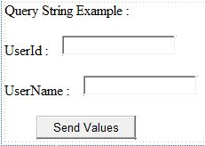

**QueryString.aspx.cs :**

using System;

using System.Collections.Generic;

using System.Linq;

using System.Web;

using System.Web.UI;

using System.Web.UI.WebControls;

public partial class QueryString : System.Web.UI.Page

{

protected void Page_Load(object sender, EventArgs e)

{

}

protected void Button1_Click(object sender, EventArgs e)

{

Response.Redirect("QueryString1.aspx?UserId=" + TextBox1.Text + "&UserName=" + TextBox2.Text);

}

}

**Source Code :**

**QueryString1.aspx :**

<%@ Page Language="C#" AutoEventWireup="true" CodeFile="QueryString1.aspx.cs" Inherits="QueryString1" %>

<!DOCTYPE html PUBLIC "-//W3C//DTD XHTML 1.0 Transitional//EN" "http://www.w3.org/TR/xhtml1/DTD/xhtml1-transitional.dtd">

<html xmlns="http://www.w3.org/1999/xhtml">

<head runat="server">

<title></title>

</head>

<body>

<form id="form1" runat="server">

<div>

<asp:Label ID="Label1" runat="server"

Text="QueryString parameter Values in QueryString1.aspx Page :"></asp:Label>

<br />

<br />

<asp:Label ID="Label2" runat="server" Text="UserId :"></asp:Label>

&nbsp;<asp:Label ID="Label4" runat="server" Text="Label"></asp:Label>

<br />

<br />

<asp:Label ID="Label3" runat="server" Text="UserName : "></asp:Label>

&nbsp;<asp:Label ID="Label5" runat="server" Text="Label"></asp:Label>

</div>

</form>

</body>

</html>

**Design…QueryString1:**

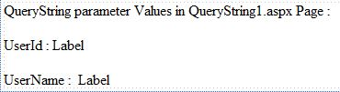

**QueryString1.aspx.cs :**

using System;

using System.Collections.Generic;

using System.Linq;

using System.Web;

using System.Web.UI;

using System.Web.UI.WebControls;

public partial class QueryString1 : System.Web.UI.Page

{

protected void Page_Load(object sender, EventArgs e)

{

if (!IsPostBack)

{

Label4.Text = Request.QueryString["UserId"];

Label5.Text = Request.QueryString["UserName"];

}

}

}

**Output :**

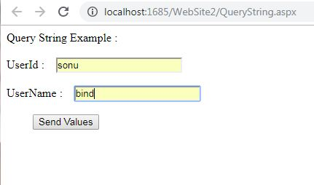

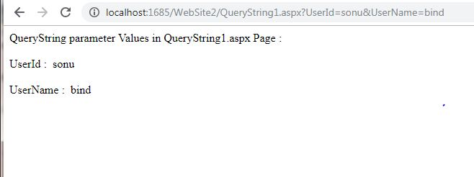

**3) CookieState :**

**Source Code :**

**Cookie.aspx :**

<%@ Page Language="C#" AutoEventWireup="true" CodeFile="Cookie.aspx.cs" Inherits="Cookie" %>

<!DOCTYPE html PUBLIC "-//W3C//DTD XHTML 1.0 Transitional//EN" "http://www.w3.org/TR/xhtml1/DTD/xhtml1-transitional.dtd">

<html xmlns="http://www.w3.org/1999/xhtml">

<head runat="server">

<title></title>

</head>

<body>

<form id="form1" runat="server">

<div>

<asp:Label ID="Label1" runat="server" Text="first name :"></asp:Label>

&nbsp;

<asp:TextBox ID="TextBox1" runat="server"></asp:TextBox>

<br />

<br />

<asp:Label ID="Label2" runat="server" Text="last name :"></asp:Label>

&nbsp;

<asp:TextBox ID="TextBox2" runat="server"></asp:TextBox>

<br />

<br />

&nbsp;&nbsp;&nbsp;&nbsp;&nbsp;

<asp:Button ID="Button1" runat="server" onclick="Button1_Click" Text="Button" />

</div>

</form>

</body>

</html>

**Design..Cookie :**

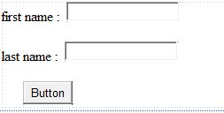

**Cookie.aspx.cs :**

using System;

using System.Collections.Generic;

using System.Linq;

using System.Web;

using System.Web.UI;

using System.Web.UI.WebControls;

public partial class Cookie : System.Web.UI.Page

{

protected void Page_Load(object sender, EventArgs e)

{

}

protected void Button1_Click(object sender, EventArgs e)

{

HttpCookie cookie=new HttpCookie("User Details");

cookie["first name"]=TextBox1.Text;

cookie["last name"] = TextBox2.Text;

cookie.Expires = DateTime.Now.AddDays(30);

Response.Cookies.Add(cookie);

Response.Redirect("Cookie1.aspx");

}

}

**Source code :**

**Cookie1.aspx :**

<%@ Page Language="C#" AutoEventWireup="true" CodeFile="Cookie1.aspx.cs" Inherits="Cookie1" %>

<!DOCTYPE html PUBLIC "-//W3C//DTD XHTML 1.0 Transitional//EN" "http://www.w3.org/TR/xhtml1/DTD/xhtml1-transitional.dtd">

<html xmlns="http://www.w3.org/1999/xhtml">

<head runat="server">

<title></title>

</head>

<body text="last name : ">

<form id="form1" runat="server">

<div>

<asp:Label ID="Label1" runat="server" Text="This is Cookie1 Page : "></asp:Label>

<br />

<br />

<asp:Label ID="Label2" runat="server" Text="first name :"></asp:Label>

&nbsp;

<asp:Label ID="Label4" runat="server" Text="Label"></asp:Label>

<br />

<br />

<asp:Label ID="Label3" runat="server" Text="last name :"></asp:Label>

&nbsp;

<asp:Label ID="Label5" runat="server" Text="Label"></asp:Label>

</div>

</form>

</body>

</html>

**Design….Cookie1 :**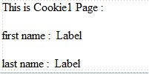

**Cookie1.aspx.cs :**

using System;

using System.Collections.Generic;

using System.Linq;

using System.Web;

using System.Web.UI;

using System.Web.UI.WebControls;

public partial class Cookie1 : System.Web.UI.Page

{

protected void Page_Load(object sender, EventArgs e)

{

HttpCookie cookie = Request.Cookies["User Details"];

if (cookie != null)

{

Label4.Text = cookie["first name"];

Label5.Text = cookie["last name"];

}

}

}

**Output :**

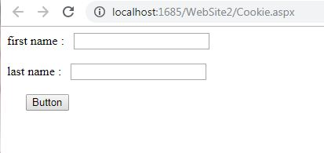

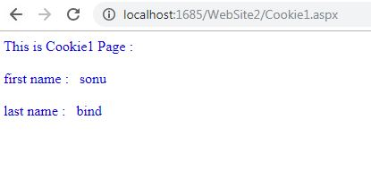

**4) SessionState :**

**Source code :**

**Default.aspx :**

<%@ Page Language="C#" EnableSessionState="True" AutoEventWireup="true" CodeFile="Default.aspx.cs" Inherits="_Default" %>

<!DOCTYPE html PUBLIC "-//W3C//DTD XHTML 1.0 Transitional//EN" "http://www.w3.org/TR/xhtml1/DTD/xhtml1-transitional.dtd">

<html xmlns="http://www.w3.org/1999/xhtml">

<head runat="server">

<title></title>

</head>

<body>

<form id="form1" runat="server">

<div>

<asp:Label ID="Label1" runat="server" Text="Name"></asp:Label>

&nbsp;

<asp:TextBox ID="TextBox1" runat="server"></asp:TextBox>

<br />

<br />

<asp:Label ID="Label2" runat="server" Text="Email"></asp:Label>

&nbsp;

<asp:TextBox ID="TextBox2" runat="server"></asp:TextBox>

<br />

&nbsp;<br />

&nbsp;&nbsp;&nbsp;&nbsp;&nbsp;&nbsp;&nbsp;

<asp:Button ID="Button1" runat="server" onclick="Button1_Click"

Text="Send Data" />

<br />

</div>

</form>

</body>

</html>

**Design ….Default**

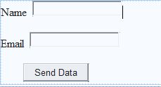

**Default.aspx.cs :**

using System;

using System.Collections.Generic;

using System.Linq;

using System.Web;

using System.Web.UI;

using System.Web.UI.WebControls;

public partial class _Default : System.Web.UI.Page

{

protected void Page_Load(object sender, EventArgs e)

{

}

protected void Button1_Click(object sender, EventArgs e)

{

Session["Name"] = TextBox1.Text;

Session["Email"] =TextBox2.Text;

Response.Redirect("WebForm.aspx");

}

}

**Source Code :**

**webForm.aspx :**

<%@ Page Language="C#" AutoEventWireup="true" CodeFile="webForm.aspx.cs" Inherits="webForm" %>

<!DOCTYPE html PUBLIC "-//W3C//DTD XHTML 1.0 Transitional//EN" "http://www.w3.org/TR/xhtml1/DTD/xhtml1-transitional.dtd">

<html xmlns="http://www.w3.org/1999/xhtml">

<head runat="server">

<title></title>

</head>

<body>

<form id="form1" runat="server">

<div>

<asp:Label ID="Label1" runat="server" Text="Name"></asp:Label>

&nbsp;

<br />

<br />

<asp:Label ID="Label2" runat="server" Text="Email"></asp:Label>

&nbsp;

<br />

<br />

&nbsp;&nbsp;&nbsp;&nbsp;&nbsp;&nbsp;&nbsp;&nbsp;&nbsp;

<asp:Button ID="Button1" runat="server" onclick="Button1_Click" Text="Button" />

</div>

</form>

</body>

</html>

**Design**….**webForm :**

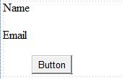

**webForm.aspx .cs :**

using System;

using System.Collections.Generic;

using System.Linq;

using System.Web;

using System.Web.UI;

using System.Web.UI.WebControls;

public partial class webForm : System.Web.UI.Page

{

protected void Page_Load(object sender, EventArgs e)

{

if (Session["Name"] != null)

{

Label1.Text = Session["Name"].ToString();

}

if (Session["Email"] != null)

{

Label2.Text = Session["Email"].ToString();

}

}

protected void Button1_Click(object sender, EventArgs e)

{

}

}

**Output :**

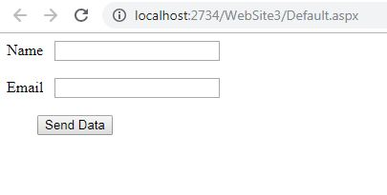

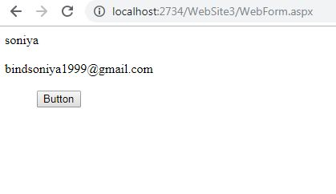

**5)Application state :**

**Source code :**

**webform1.aspx :**

<%@ Page Language="C#" AutoEventWireup="true" CodeFile="webform1.aspx.cs" Inherits="webform1" %>

<!DOCTYPE html PUBLIC "-//W3C//DTD XHTML 1.0 Transitional//EN" "http://www.w3.org/TR/xhtml1/DTD/xhtml1-transitional.dtd">

<html xmlns="http://www.w3.org/1999/xhtml">

<head runat="server">

<title></title>

</head>

<body>

<form id="form1" runat="server">

<asp:Label ID="Label1" runat="server" Text="Name :"></asp:Label>

&nbsp;

<asp:TextBox ID="TextBox1" runat="server"></asp:TextBox>

<br />

<br />

<asp:Label ID="Label2" runat="server" Text="Email :"></asp:Label>

&nbsp;

<asp:TextBox ID="TextBox2" runat="server"></asp:TextBox>

<br />

<br />

&nbsp;&nbsp;&nbsp;

<asp:Button ID="Button1" runat="server" onclick="Button1_Click"

Text="Send Data" />

</form>

</body>

</html>

**Design…webform1**

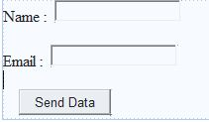

**webform1.aspx.cs :**

using System;

using System.Collections.Generic;

using System.Linq;

using System.Web;

using System.Web.UI;

using System.Web.UI.WebControls;

public partial class webform1 : System.Web.UI.Page

{

protected void Page_Load(object sender, EventArgs e)

{

}

protected void Button1_Click(object sender, EventArgs e)

{

Application["Name"] = TextBox1.Text;

Application["Email"] = TextBox2.Text;

Response.Redirect("WebForm2.aspx");

}

}

**Source code :**

**webform2.aspx :**

<%@ Page Language="C#" AutoEventWireup="true" CodeFile="webform2.aspx.cs" Inherits="webform2" %>

<!DOCTYPE html PUBLIC "-//W3C//DTD XHTML 1.0 Transitional//EN" "http://www.w3.org/TR/xhtml1/DTD/xhtml1-transitional.dtd">

<html xmlns="http://www.w3.org/1999/xhtml">

<head runat="server">

<title></title>

</head>

<body>

<form id="form1" runat="server">

<div>

<asp:Label ID="Label1" runat="server" Text="Name :"></asp:Label>

<br />

<br />

<asp:Label ID="Label2" runat="server" Text="Email :"></asp:Label>

<br />

<br />

&nbsp;&nbsp;&nbsp;&nbsp;&nbsp;&nbsp;

<asp:Button ID="Button1" runat="server" onclick="Button1_Click" Text="Button" />

</div>

</form>

</body>

</html>

**Design….webform2 :**

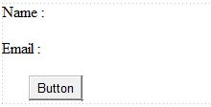

**webform2.aspx.cs**

using System;

using System.Collections.Generic;

using System.Linq;

using System.Web;

using System.Web.UI;

using System.Web.UI.WebControls;

public partial class webform2 : System.Web.UI.Page

{

protected void Page_Load(object sender, EventArgs e)

{

if (Application["Name"] != null)

{

Label1.Text = Application["Name"].ToString();

}

if (Application["Email"] != null)

{

Label2.Text = Application["Email"].ToString();

}

}

protected void Button1_Click(object sender, EventArgs e)

{

}

}

**Output :**

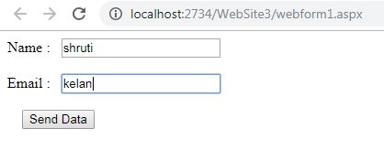

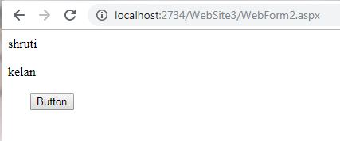

**Practical No.6(a)**

**Problem Statement** :- create a web application to bind data in a multiline textbox by querying in another textbox

**Database project** :

**Web.config** :

<?xml version="1.0"?>

<!--

For more information on how to configure your ASP.NET application, please visit

http://go.microsoft.com/fwlink/?LinkId=169433

-->

<configuration>

<system.web>

<compilation debug="false" targetFramework="4.0" />

</system.web>

<connectionStrings>

<add name="connStr" connectionString="Data Source=’SQLEXPRESS;AttachDbFilename=D:\sonu\TYIT\data\App_Data\Data.mdf ‘;Integrated Security=True;User Instance=True"></add>

</connectionStrings>

</configuration>

**Source code** :

**Practical6(a).aspx**

<%@ Page Language="C#" AutoEventWireup="true" CodeFile="practical6(a).aspx.cs" Inherits="practical6_a_" %>

<!DOCTYPE html PUBLIC "-//W3C//DTD XHTML 1.0 Transitional//EN" "http://www.w3.org/TR/xhtml1/DTD/xhtml1-transitional.dtd">

<html xmlns="http://www.w3.org/1999/xhtml">

<head runat="server">

<title></title>

</head>

<body>

<form id="form1" runat="server">

<div>

<asp:TextBox ID="TextBox1" runat="server" TextMode="MultiLine"></asp:TextBox>

<br />

<br />

<br />

<br />

<asp:ListBox ID="ListBox1" runat="server" Height="106px"

style="margin-bottom: 38px" Width="165px"></asp:ListBox>

<br />

<br />

<br />

<asp:Button ID="Button1" runat="server" onclick="Button1_Click" Text="Button"

Width="139px" />

</div>

</form>

</body>

</html>

**Practical6(a).aspx.cs**

using System;

using System.Collections.Generic;

using System.Linq;

using System.Web;

using System.Web.UI;

using System.Web.UI.WebControls;

using System.Data;

using System.Data.SqlClient;

using System.Configuration;

public partial class practical6_a_ : System.Web.UI.Page

{

protected void Page_Load(object sender, EventArgs e)

{

}

protected void Button1_Click(object sender, EventArgs e)

{

string connStr =

ConfigurationManager.ConnectionStrings["connStr"].ConnectionString;

SqlConnection con = new SqlConnection(connStr);

con.Open();

SqlCommand cmd = new SqlCommand(TextBox1.Text, con);

SqlDataReader reader = cmd.ExecuteReader();

ListBox1.Items.Clear();

while (reader.Read())

{

for (int i = 0; i < reader.FieldCount - 1; i++)

{

ListBox1.Items.Add(reader[i].ToString());

}

}

reader.Close();

con.Close();

}

}

**Design**…..**practical6(a)** :

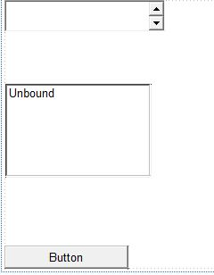

**Solution Explorer : ..1)Data.mdf 2)Practical6(a).aspx 3)Practical6(a).aspx.cs**

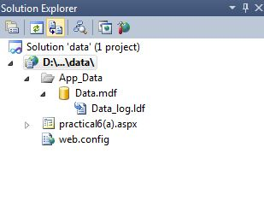

**Connection** :

Right click on **Data.mdf**

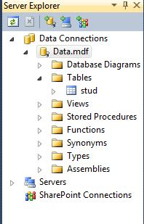

and go to property…and copy **connection String** and paste into **web.config**

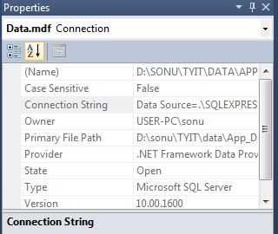

**Create table** :

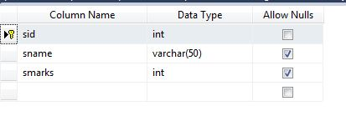

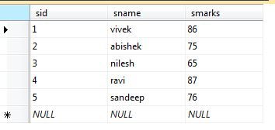

**Output** :

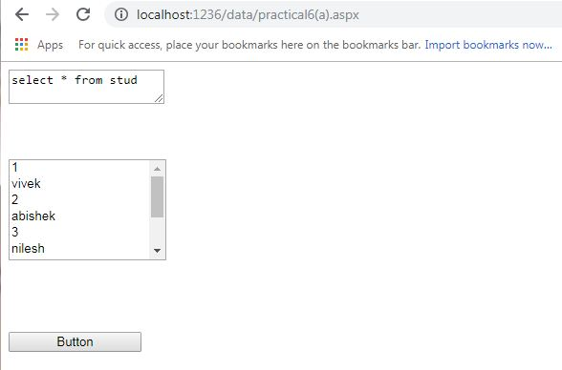

**Practical No.6(b)**

**Note** : As above practical6(a) we had create one database connection and table also using this one in further practica6(b)..and so on

**Problem Statement** :-Create a web application to display records by using database

**Web.config**:

<?xml version="1.0"?>

<!--

For more information on how to configure your ASP.NET application, please visit

http://go.microsoft.com/fwlink/?LinkId=169433

-->

<configuration>

<system.web>

<compilation debug="false" targetFramework="4.0" />

</system.web>

<connectionStrings>

<add name="connStr" connectionString="Data Source=.\SQLEXPRESS;AttachDbFilename=D:\sonu\TYIT\data\App_Data\Data.mdf;Integrated Security=True;User Instance=True"></add>

</connectionStrings>

</configuration>

**Source code** :

**practical6(b).aspx** :

<%@ Page Language="C#" AutoEventWireup="true" CodeFile="practical6(b).aspx.cs" Inherits="practical6_b_" %>

<!DOCTYPE html PUBLIC "-//W3C//DTD XHTML 1.0 Transitional//EN" "http://www.w3.org/TR/xhtml1/DTD/xhtml1-transitional.dtd">

<html xmlns="http://www.w3.org/1999/xhtml">

<head runat="server">

<title></title>

</head>

<body>

<form id="form1" runat="server">

<div>

<asp:Label ID="Label1" runat="server" Text="Student Details :"></asp:Label>

<br />

<br />

<br />

<asp:Label ID="Label2" runat="server" Text="Label"></asp:Label>

<br />

<br />

<br />

<br />

<br />

<asp:Button ID="Button1" runat="server" onclick="Button1_Click"

Text="Display Records" />

</div>

</form>

</body>

</html>

**practical6(b).aspx.cs** :

using System;

using System.Collections.Generic;

using System.Linq;

using System.Web;

using System.Web.UI;

using System.Web.UI.WebControls;

using System.Data;

using System.Data.SqlClient;

using System.Configuration;

public partial class practical6_b_ : System.Web.UI.Page

{

protected void Page_Load(object sender, EventArgs e)

{

}

protected void Button1_Click(object sender, EventArgs e)

{

string connStr =

ConfigurationManager.ConnectionStrings["connStr"].ConnectionString;

SqlConnection con = new SqlConnection(connStr);

SqlCommand cmd = new SqlCommand("select sid,sname from stud", con);

con.Open();

SqlDataReader reader = cmd.ExecuteReader();

while (reader.Read())

{

Label2.Text += reader["sid"].ToString() + "" + reader["sname"].ToString() + "<br>";

}

reader.Close();

con.Close();

}

}

**Design..Pactical6(b)** :

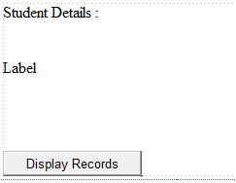

**Output** :

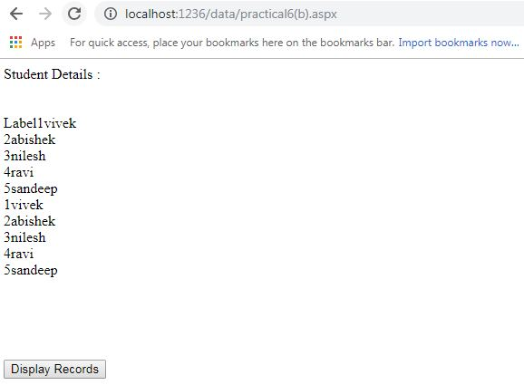

**Practical No .6(c)**

**Problem Statement** :- Demonstrate the use of Datalist link control.

**Source code** :

**practical6(c).aspx** :

<%@ Page Language="C#" AutoEventWireup="true" CodeFile="practical6(c).aspx.cs" Inherits="practical6_c_" %>

<!DOCTYPE html PUBLIC "-//W3C//DTD XHTML 1.0 Transitional//EN" "http://www.w3.org/TR/xhtml1/DTD/xhtml1-transitional.dtd">

<html xmlns="http://www.w3.org/1999/xhtml">

<head runat="server">

<title></title>

</head>

<body>

<form id="form1" runat="server">

<div>

</div>

<asp:DataList ID="DataList1" runat="server">

</asp:DataList>

</form>

</body>

</html>

**Design..practical6(c)** :

For Datalist link control we need certain steps :

**Step 1**:

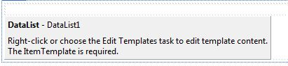

**Step 2** :

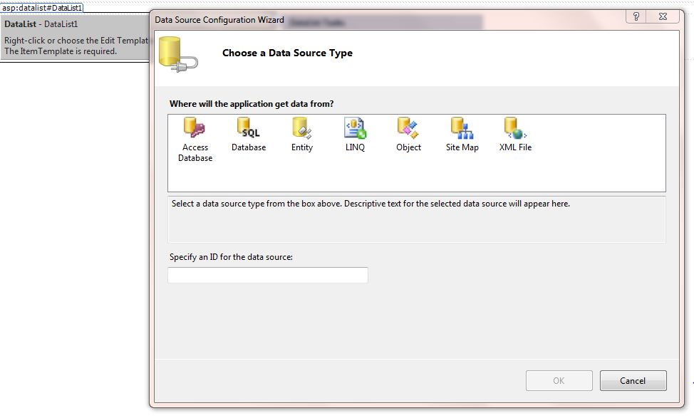

**Step 3**:

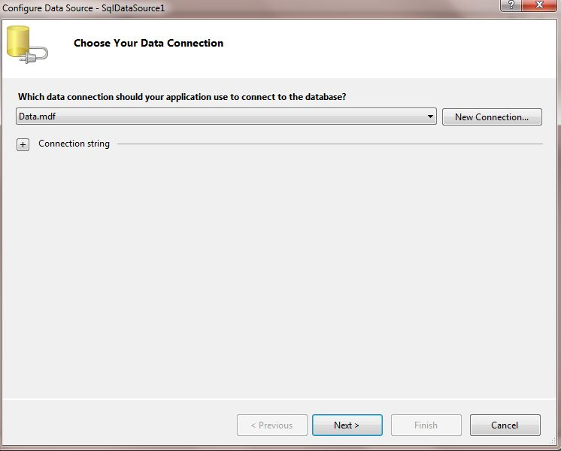

**Step 4** :

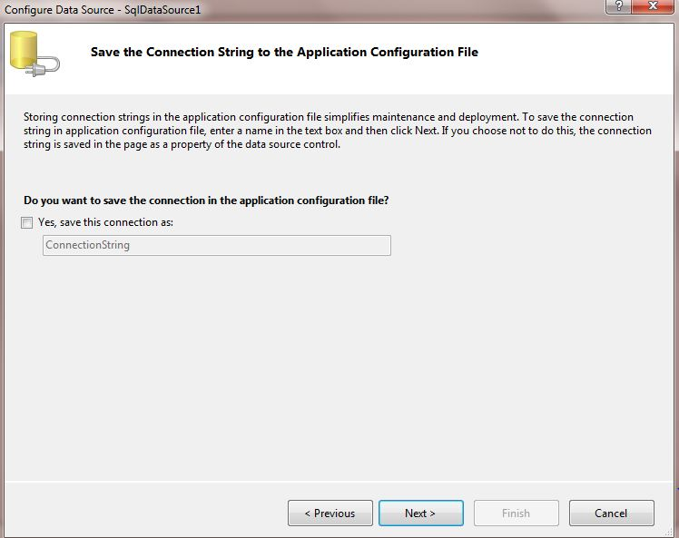

**Step 5** :

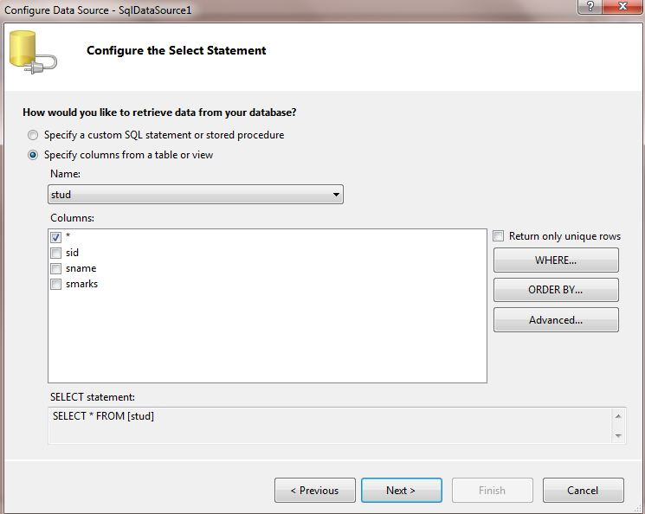

**Step 6** :

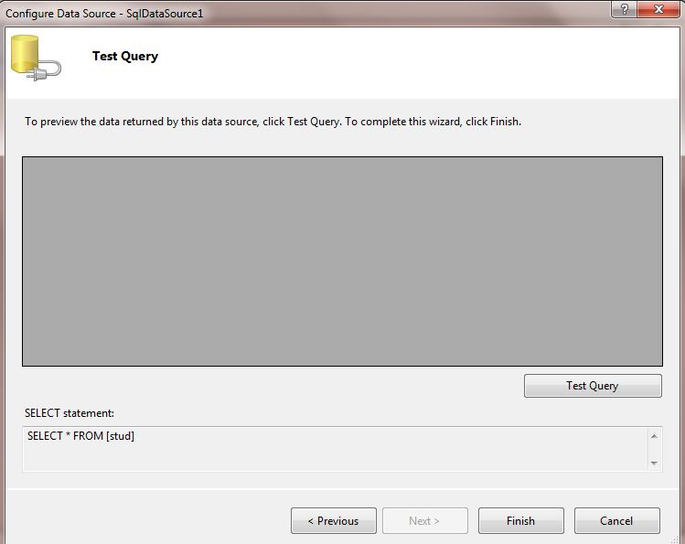

**Step 7** :

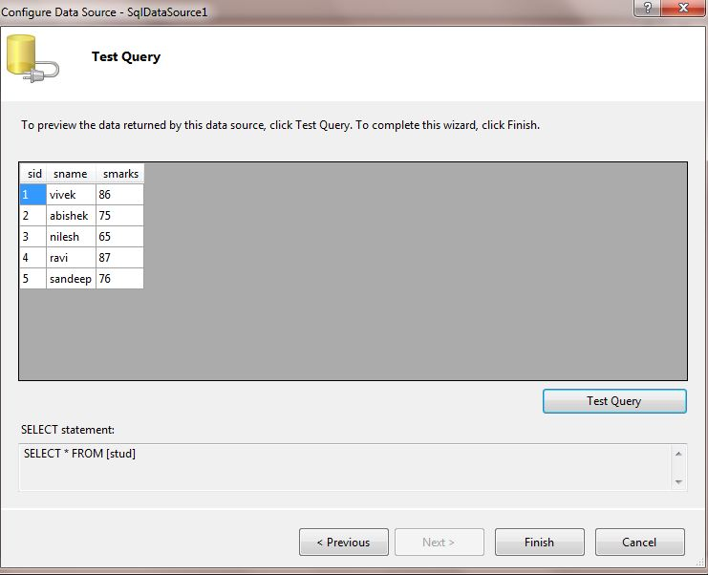

**Step 8**:

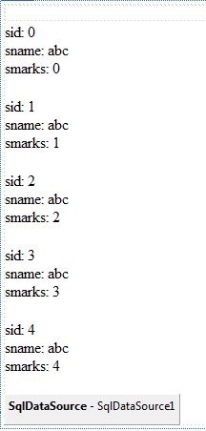

**Output** :

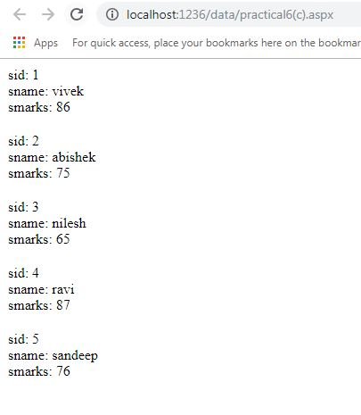

**Practical No.7(a)**

**Problem statement** : Create a web application to display Databinding using DropDownlist control

**Note** :In that The Databinding to DropDownList can be done using visual studio options to select the Data Source, The step is similar as performed in practical6(c)

**Web.config** :

<?xml version="1.0"?>

<!--

For more information on how to configure your ASP.NET application, please visit

http://go.microsoft.com/fwlink/?LinkId=169433

-->

<configuration>

<system.web>

<compilation debug="false" targetFramework="4.0" />

</system.web>

<connectionStrings>

<add name="connStr" connectionString="Data Source=.\SQLEXPRESS;AttachDbFilename=D:\sonu\TYIT\data\App_Data\Data.mdf;Integrated Security=True;User Instance=True"></add>

</connectionStrings>

</configuration>

**Source code** :

**Practical7(a).aspx**:

<%@ Page Language="C#" AutoEventWireup="true" CodeFile="practical7(a).aspx.cs" Inherits="practical7_a_" %>

<!DOCTYPE html PUBLIC "-//W3C//DTD XHTML 1.0 Transitional//EN" "http://www.w3.org/TR/xhtml1/DTD/xhtml1-transitional.dtd">

<html xmlns="http://www.w3.org/1999/xhtml">

<head runat="server">

<title></title>

</head>

<body>

<form id="form1" runat="server">

<div>

<asp:DropDownList ID="DropDownList1" runat="server"

DataTextField="sname" DataValueField="sname">

</asp:DropDownList>

<asp:SqlDataSource ID="SqlDataSource1" runat="server"

ConnectionString="Data Source=.\SQLEXPRESS;AttachDbFilename=|DataDirectory|\Data.mdf;Integrated Security=True;User Instance=True"

ProviderName="System.Data.SqlClient" SelectCommand="SELECT [sname] FROM [stud]">

</asp:SqlDataSource>

<br />

<br />

<br />

<asp:Button ID="Button1" runat="server" onclick="Button1_Click"

Text="Click Me !" />

<br />

<br />

<br />

<asp:Label ID="Label1" runat="server" Text="Label"></asp:Label>

</div>

</form>

</body>

</html>

**practical.aspx.cs** :

using System;

using System.Collections.Generic;

using System.Linq;

using System.Web;

using System.Web.UI;

using System.Web.UI.WebControls;

using System.Data;

using System.Data.SqlClient;

using System.Configuration;

using System.Data;

using System.Data.SqlClient;

using System.Configuration;

public partial class practical7_a_ : System.Web.UI.Page

{

protected void Page_Load(object sender, EventArgs e)

{

if (IsPostBack == false)

{

string connStr =

ConfigurationManager.ConnectionStrings["connStr"].ConnectionString;

SqlConnection con = new SqlConnection(connStr);

SqlCommand cmd = new SqlCommand("select Distinct sname from stud", con);

con.Open();

SqlDataReader reader = cmd.ExecuteReader();

DropDownList1.DataSource = reader;

DropDownList1.DataTextField = "sname";

DropDownList1.DataBind();

reader.Close();

con.Close();

}

}

protected void Button1_Click(object sender, EventArgs e)

{

Label1.Text = "The name you selected is :" + DropDownList1.SelectedValue;

}

}

**Desing..practical7(a) :**

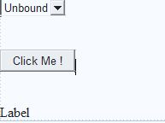

**Note** :The output can become either two way one is through **coding** in **.cs file**

(**Or we can follow certain steps as given below**)

**Step 1**:

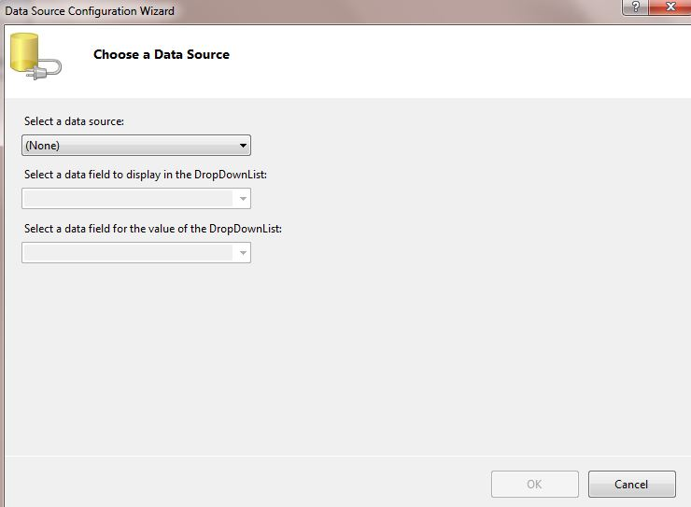

**Step 2:**

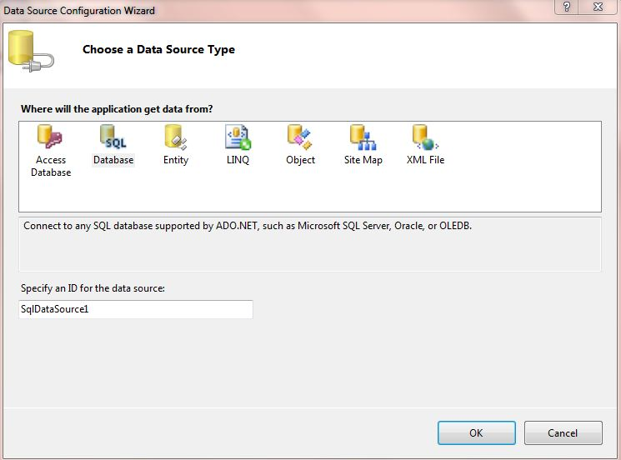

**Step 3**:

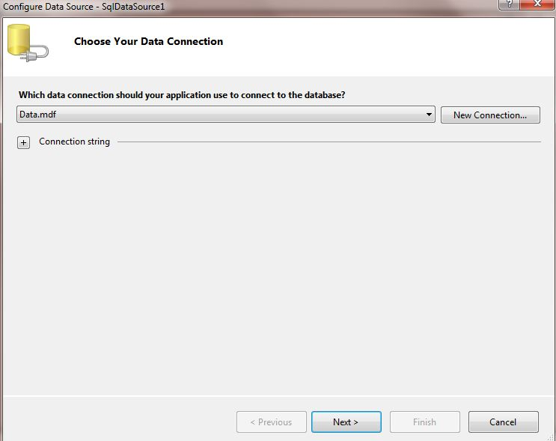

**Step 4** :

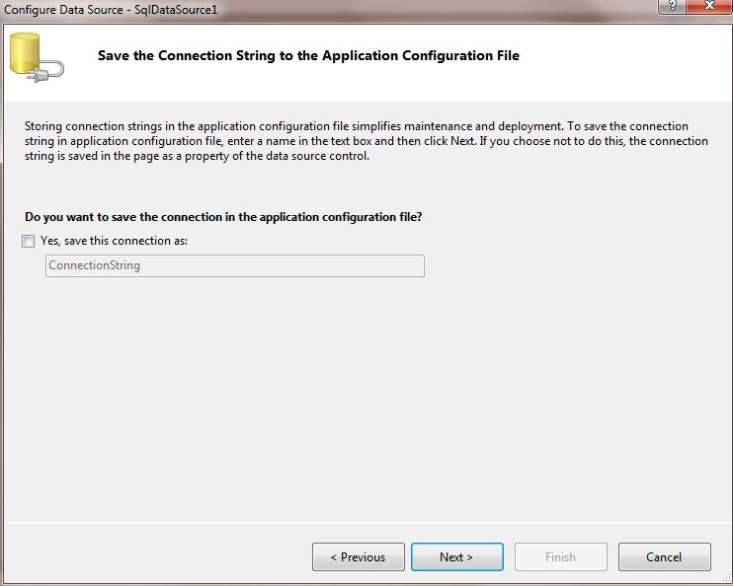

**Step 5** :

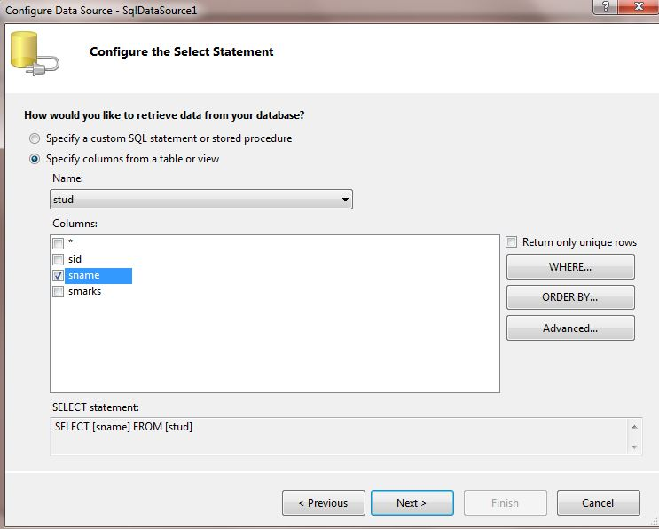

**Step 6**:

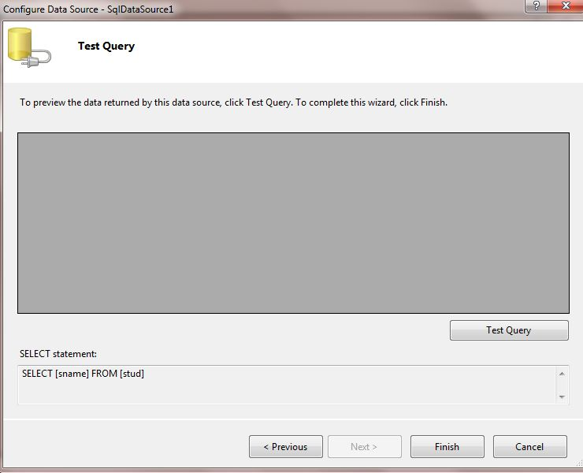

**Step 7** :

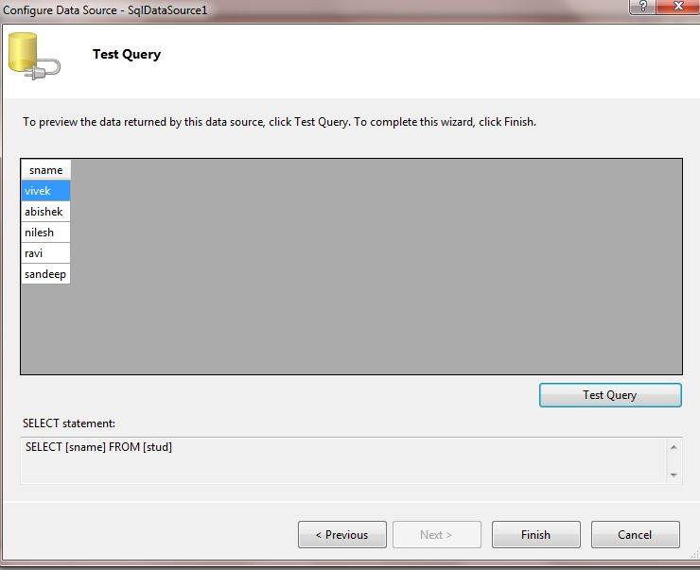

**Step 8**:

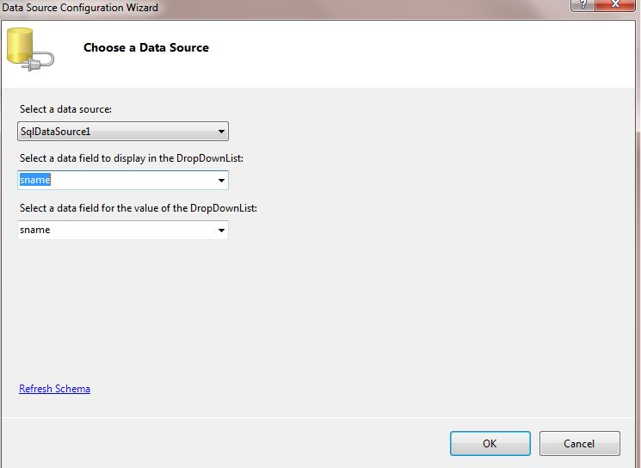

**Step 9** :

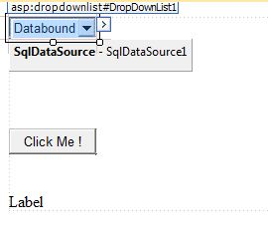

**Output** :

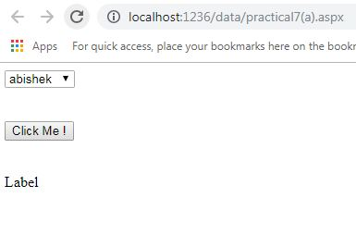

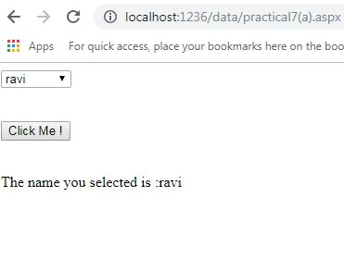

**Practical No.7(b)**

**Problem statement** :- Create a web application for to display the marks of students using database.

**Web.config** :

<?xml version="1.0"?>

<!--

For more information on how to configure your ASP.NET application, please visit

http://go.microsoft.com/fwlink/?LinkId=169433

-->

<configuration>

<system.web>

<compilation debug="false" targetFramework="4.0" />

</system.web>

<connectionStrings>

<add name="connStr" connectionString="Data Source=.\SQLEXPRESS;AttachDbFilename=D:\sonu\TYIT\data\App_Data\Data.mdf;Integrated Security=True;User Instance=True"></add>

</connectionStrings>

</configuration>

Source code :

Practical7(b).aspx :

<%@ Page Language="C#" AutoEventWireup="true" CodeFile="practcal7(b).aspx.cs" Inherits="practcal7_b_" %>

<!DOCTYPE html PUBLIC "-//W3C//DTD XHTML 1.0 Transitional//EN" "http://www.w3.org/TR/xhtml1/DTD/xhtml1-transitional.dtd">

<html xmlns="http://www.w3.org/1999/xhtml">

<head runat="server">

<title></title>

</head>

<body>

<form id="form1" runat="server">

<div>

<asp:Label ID="Label1" runat="server"

Text="Select your name to get your marks :"></asp:Label>

<br />

<br />

<asp:DropDownList ID="DropDownList1" runat="server" //DataSourceID=”SqlDataSource1” Note:REMOVE IT

DataTextField="sname" DataValueField="smarks">

</asp:DropDownList>

<asp:SqlDataSource ID="SqlDataSource1" runat="server"

ConnectionString="Data Source=.\SQLEXPRESS;AttachDbFilename=|DataDirectory|\Data.mdf;Integrated Security=True;User Instance=True"

ProviderName="System.Data.SqlClient"

SelectCommand="SELECT [sname], [smarks] FROM [stud]"></asp:SqlDataSource>

<br />

<br />

<br />

<asp:Button ID="Button1" runat="server" onclick="Button1_Click"

Text="Get Marks" />

<br />

<br />

<br />

<asp:Label ID="Label2" runat="server" Text="Label"></asp:Label>

</div>

</form>

</body>

</html>

**Practical7(b).aspx.cs** :

using System;

using System.Collections.Generic;

using System.Linq;

using System.Web;

using System.Web.UI;

using System.Web.UI.WebControls;

using System.Data;

using System.Data.SqlClient;

using System.Configuration;

public partial class practcal7_b_ : System.Web.UI.Page

{

protected void Page_Load(object sender, EventArgs e)

{

if (IsPostBack == false)

{

string connStr =

ConfigurationManager.ConnectionStrings["connStr"].ConnectionString;

SqlConnection con = new SqlConnection(connStr);

SqlCommand cmd = new SqlCommand("select Distinct sname,smarks from stud", con);

con.Open();

SqlDataReader reader = cmd.ExecuteReader();

DropDownList1.DataSource = reader;

DropDownList1.DataTextField = "sname";

DropDownList1.DataValueField = "smarks";

DropDownList1.DataBind();

reader.Close();

con.Close();

}

}

protected void Button1_Click(object sender, EventArgs e)

{

Label2.Text = "Your Marks is :" + DropDownList1.SelectedValue;

}

}

Design…prctical7(b):

In design Take 1…Label 2..DropDownLis 3..Button 4..Label

Here is also same

1.**Through coding**

**..OR..**

Follow certain step :

**Step 1** :

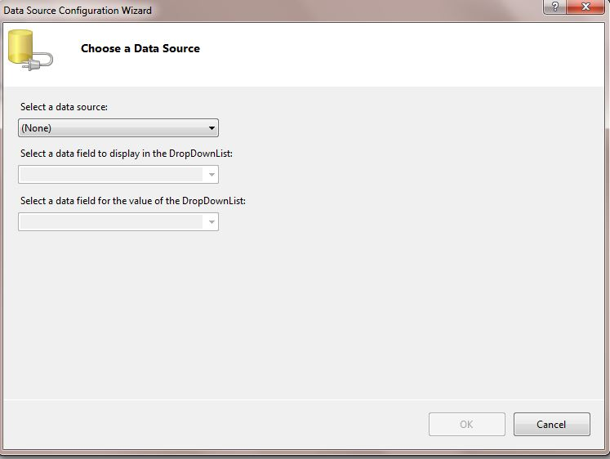

**Step2**:

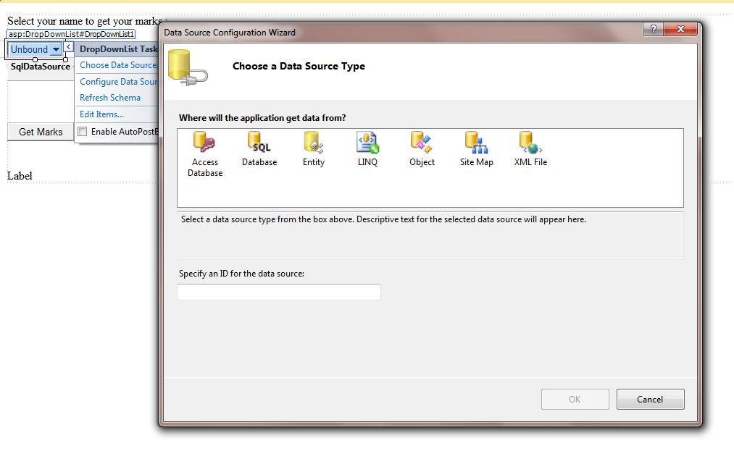

**Step 3**

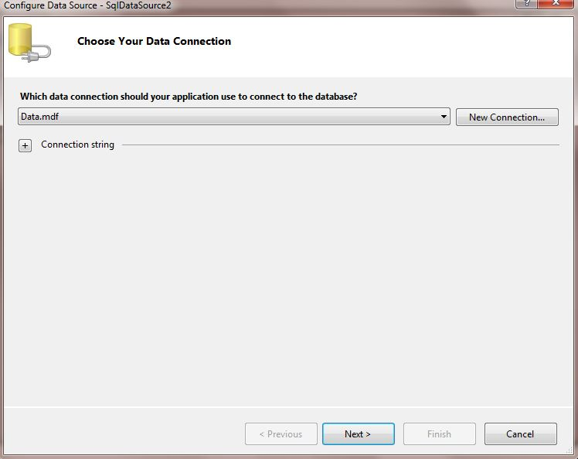

**Step4**:

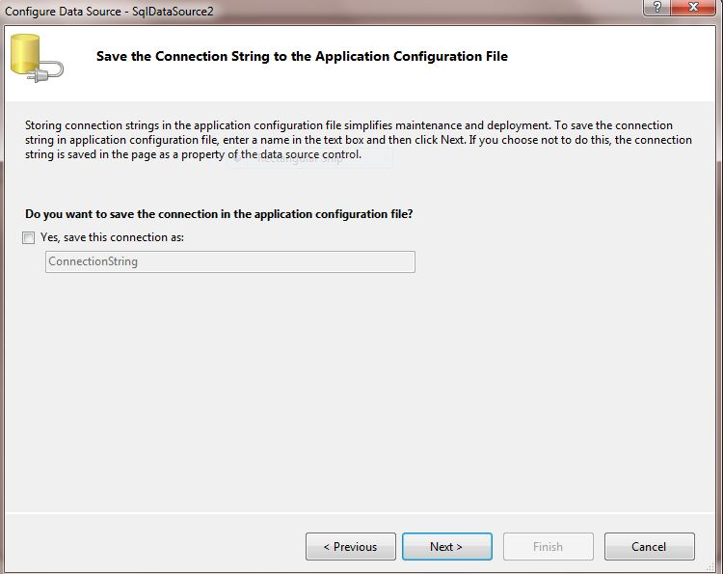

**Step 5** :

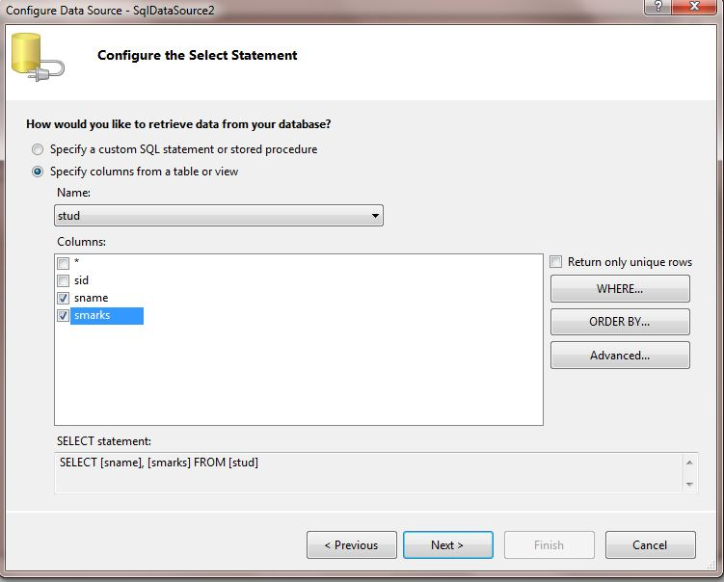

**Step 6**:

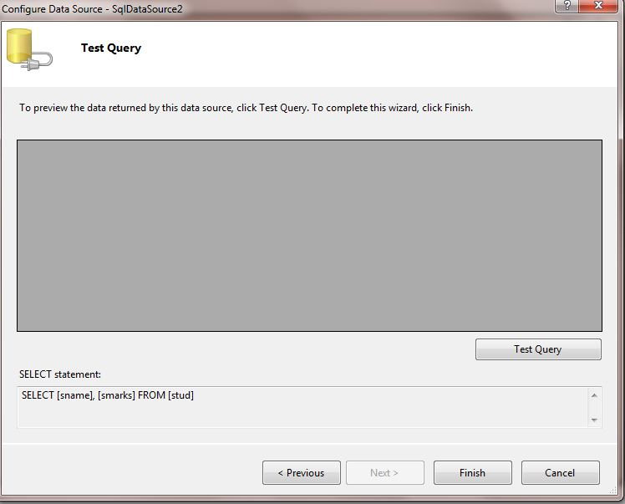

**Step 7**:

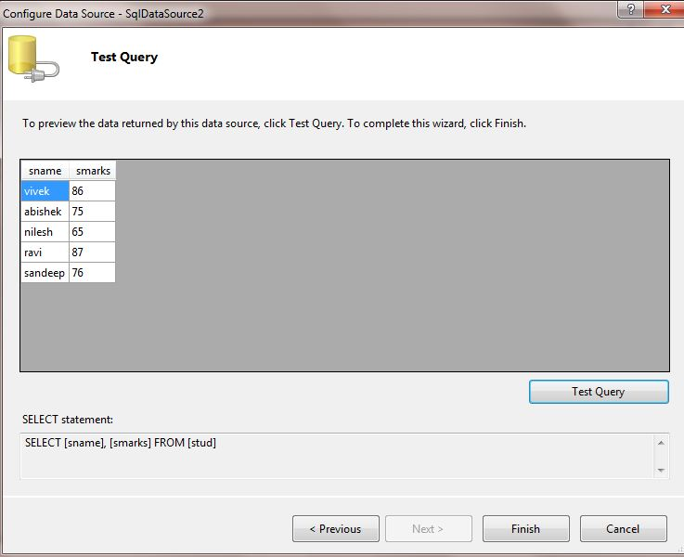

**Step8**:

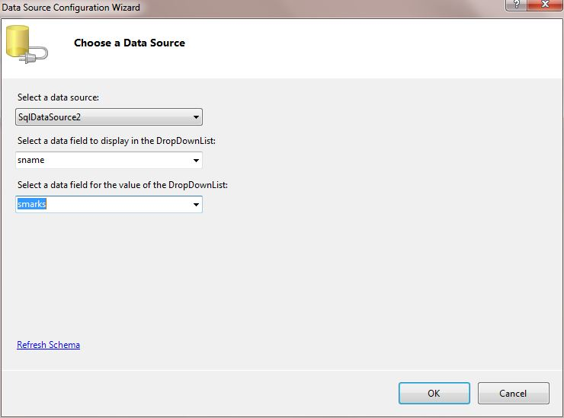

**Step 9** :

2)

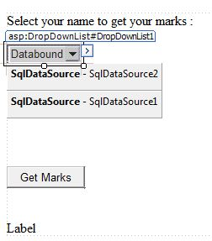

1)

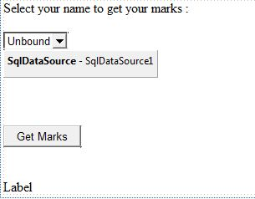

**Output** :

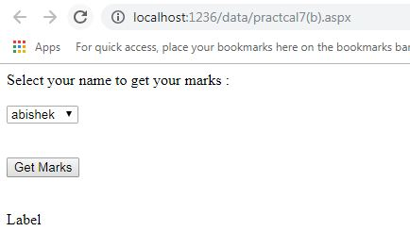

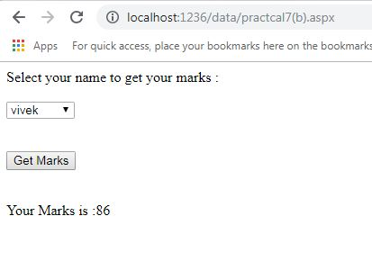

**Practical No.7(c)**

**Problem Statement** :- Create a web application for inserting and deleting record from a database.(Using Execute –Non Query).

**Web.config :**

<?xml version="1.0"?>

<!--

For more information on how to configure your ASP.NET application, please visit

http://go.microsoft.com/fwlink/?LinkId=169433

-->

<configuration>

<system.web>

<compilation debug="false" targetFramework="4.0" />

</system.web>

<connectionStrings>

<add name="connStr" connectionString="Data Source=.\SQLEXPRESS;AttachDbFilename=D:\sonu\TYIT\data\App_Data\Data.mdf;Integrated Security=True;User Instance=True"></add>

</connectionStrings>

</configuration>

**Source code** :

**Practical7(c).aspx** :

<%@ Page Language="C#" AutoEventWireup="true" CodeFile="practical7(c).aspx.cs" Inherits="practical7_c_" %>

<!DOCTYPE html PUBLIC "-//W3C//DTD XHTML 1.0 Transitional//EN" "http://www.w3.org/TR/xhtml1/DTD/xhtml1-transitional.dtd">

<html xmlns="http://www.w3.org/1999/xhtml">

<head runat="server">

<title></title>

</head>

<body>

<form id="form1" runat="server">

<div>

<asp:Label ID="Label1" runat="server" Text="Enter student ID :"></asp:Label>

&nbsp;

<asp:TextBox ID="TextBox1" runat="server"></asp:TextBox>

<br />

<br />

<asp:Label ID="Label2" runat="server" Text="Enter student name :"></asp:Label>

&nbsp;

<asp:TextBox ID="TextBox2" runat="server"></asp:TextBox>

<br />

<br />

<asp:Label ID="Label3" runat="server" Text="Enter student marks :"></asp:Label>

&nbsp;

<asp:TextBox ID="TextBox3" runat="server"></asp:TextBox>

<br />

<br />

<asp:Label ID="Label4" runat="server" Text="Label"></asp:Label>

<br />

<br />

<asp:Button ID="Button1" runat="server" onclick="Button1_Click"

Text="Insert Record" />

&nbsp;&nbsp;&nbsp;

<asp:Button ID="Button2" runat="server" onclick="Button2_Click"

Text="delete Record" />

</div>

</form>

</body>

</html>

**Practical7(c).aspx.cs** :

using System;

using System.Collections.Generic;

using System.Linq;

using System.Web;

using System.Web.UI;

using System.Web.UI.WebControls;

using System.Data;

using System.Data.SqlClient;

using System.Configuration;

public partial class practical7_c_ : System.Web.UI.Page

{

protected void Page_Load(object sender, EventArgs e)

{

}

protected void Button1_Click(object sender, EventArgs e)

{

string connStr =

ConfigurationManager.ConnectionStrings["connStr"].ConnectionString;

SqlConnection con = new SqlConnection(connStr);

string InsertQuery = "insert into stud values(@sid,@sname,@smarks)";

SqlCommand cmd = new SqlCommand(InsertQuery, con);

cmd.Parameters.AddWithValue("@sid", TextBox1.Text);

cmd.Parameters.AddWithValue("@sname", TextBox2.Text);

cmd.Parameters.AddWithValue("@smarks", TextBox3.Text);

con.Open();

cmd.ExecuteNonQuery();

Label4.Text = "Recored Inserted Successfully";

con.Close();

}

protected void Button2_Click(object sender, EventArgs e)

{

string connStr =

ConfigurationManager.ConnectionStrings["connStr"].ConnectionString;

SqlConnection con = new SqlConnection(connStr);

string InsertQuery = "delete from stud where sid=@sid";

SqlCommand cmd = new SqlCommand(InsertQuery, con);

cmd.Parameters.AddWithValue("@sid", TextBox1.Text);

// cmd.Parameters.AddWithValue("@sname", TextBox2.Text);

// cmd.Parameters.AddWithValue("@smarks", TextBox3.Text);

con.Open();

cmd.ExecuteNonQuery();

Label4.Text = "Recored Deleted Successfully";

con.Close();

}

}

**Design..practical7(c)** :

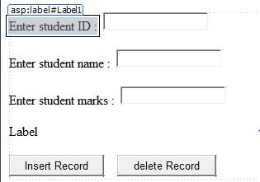

**Table :**

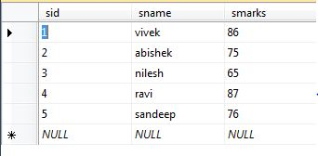

**Output** :

When you **insert** record in **table** :

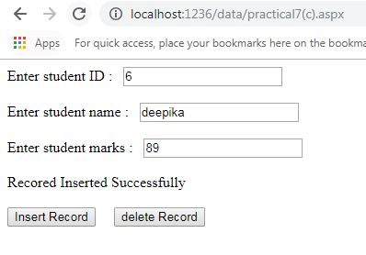

The **table** will be :

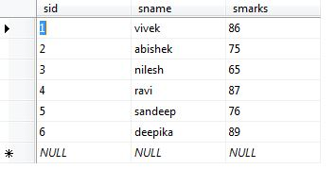

When you **delete** some records in **table** :

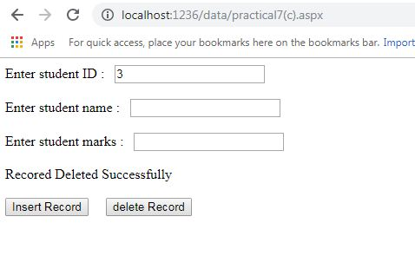

The **table** will be :

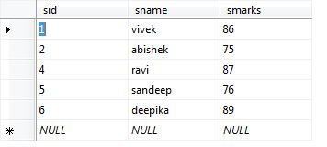

**Practical No.8(a)**

## **Problem Statement: Create a web application to demonstrate various uses and properties of SqlDataSource**

## **Source code** :

## **8a.aspx.cs :**

<%@ Page Language="C#" AutoEventWireup="true" CodeFile="8a.aspx.cs" Inherits="_8a" %>

<!DOCTYPE html PUBLIC "-//W3C//DTD XHTML 1.0 Transitional//EN" "<http://www.w3.org/TR/xhtml1/DTD/xhtml1-transitional.dtd>">

<html xmlns="<http://www.w3.org/1999/xhtml>">

<head runat="server">

<title></title>

</head>

<body>

<form id="form1" runat="server">

<div>

<asp:DropDownList ID="DropDownList1" runat="server" AutoPostBack="True" DataSourceID="SqlDataSource1" DataTextField="sname" DataValueField="sname" onselectedindexchanged="DropDownList1_SelectedIndexChanged">

</asp:DropDownList>

<asp:SqlDataSource ID="SqlDataSource1" runat="server" ConnectionString="Data Source=DESKTOP-E28D6T8;Initial

Catalog=AwpPractical;Integrated Security=True" ProviderName="System.Data.SqlClient"

SelectCommand="SELECT [sname] FROM [student]"></asp:SqlDataSource>

<asp:DataList ID="DataList1" runat="server" DataSourceID="SqlDataSource2">

<ItemTemplate> sid:

<asp:Label ID="sidLabel" runat="server" Text='<%# Eval("sid") %>' />

<br /> sname:

<asp:Label ID="snameLabel" runat="server" Text='<%# Eval("sname") %>' />

<br /> smarks:

<asp:Label ID="smarksLabel" runat="server" Text='<%# Eval("smarks") %>'

/>

<br />

<br />

</ItemTemplate>

</asp:DataList>

<br />

<asp:SqlDataSource ID="SqlDataSource2" runat="server" ConnectionString="Data Source=DESKTOP-E28D6T8;Initial

Catalog=AwpPractical;Integrated Security=True" ProviderName="System.Data.SqlClient"

SelectCommand="SELECT * FROM [student] WHERE ([sname] = @sname)" >

<SelectParameters>

<asp:ControlParameter ControlID="DropDownList1" Name="sname" PropertyName="SelectedValue" Type="String" />

</SelectParameters>

</asp:SqlDataSource>

</div>

</form>

</body>

</html>

**Design…..8(a)**

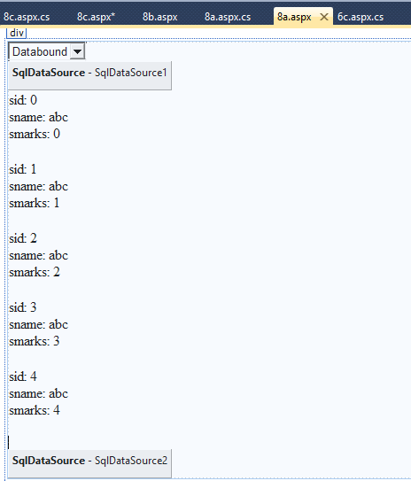

**Output**:

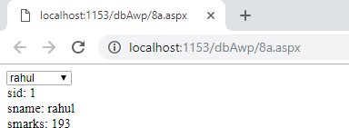

**PracticalNo.8(b)**

**Problem statements** :- Create a web application to demonstrate data binding using Details View and Form View Control

**Web.config** :

<?xml version="1.0"?>

<!--

For more information on how to configure your ASP.NET application, please visit

http://go.microsoft.com/fwlink/?LinkId=169433

-->

<configuration>

<system.web>

<compilation debug="true" targetFramework="4.0"/>

</system.web>

<connectionStrings>

<add name="connStr" connectionString="Data Source=.\SQLEXPRESS;AttachDbFilename=D:\sonu\TYIT\data\App_Data\Data.mdf;Integrated Security=True;User Instance=True"></add>

</connectionStrings>

</configuration>

**Source code** :

**Practical8(b).aspx** :

<%@ Page Language="C#" AutoEventWireup="true" CodeFile="practical8(b).aspx.cs" Inherits="practical8_b_" %>

<!DOCTYPE html PUBLIC "-//W3C//DTD XHTML 1.0 Transitional//EN" "http://www.w3.org/TR/xhtml1/DTD/xhtml1-transitional.dtd">

<html xmlns="http://www.w3.org/1999/xhtml">

<head runat="server">

<title></title>

</head>

<body>

<form id="form1" runat="server">

<div>

<asp:DetailsView ID="DetailsView1" runat="server" AutoGenerateRows="False"

DataKeyNames="sid" DataSourceID="SqlDataSource1" Height="50px" Width="125px">

<Fields>

<asp:BoundField DataField="sid" HeaderText="sid" ReadOnly="True"

SortExpression="sid" />

<asp:BoundField DataField="sname" HeaderText="sname" SortExpression="sname" />

<asp:BoundField DataField="smarks" HeaderText="smarks"

SortExpression="smarks" />

</Fields>

</asp:DetailsView>

<asp:SqlDataSource ID="SqlDataSource1" runat="server"

ConnectionString="Data Source=.\SQLEXPRESS;AttachDbFilename=|DataDirectory|\Data.mdf;Integrated Security=True;User Instance=True"

ProviderName="System.Data.SqlClient" SelectCommand="SELECT * FROM [stud]">

</asp:SqlDataSource>

<br />

<asp:FormView ID="FormView1" runat="server" DataKeyNames="sid"

DataSourceID="SqlDataSource2">

<EditItemTemplate>

sid:

<asp:Label ID="sidLabel1" runat="server" Text='<%# Eval("sid") %>' />

<br />

sname:

<asp:TextBox ID="snameTextBox" runat="server" Text='<%# Bind("sname") %>' />

<br />

smarks:

<asp:TextBox ID="smarksTextBox" runat="server" Text='<%# Bind("smarks") %>' />

<br />

<asp:LinkButton ID="UpdateButton" runat="server" CausesValidation="True"

CommandName="Update" Text="Update" />

&nbsp;<asp:LinkButton ID="UpdateCancelButton" runat="server"

CausesValidation="False" CommandName="Cancel" Text="Cancel" />

</EditItemTemplate>

<InsertItemTemplate>

sid:

<asp:TextBox ID="sidTextBox" runat="server" Text='<%# Bind("sid") %>' />

<br />

sname:

<asp:TextBox ID="snameTextBox" runat="server" Text='<%# Bind("sname") %>' />

<br />

smarks:

<asp:TextBox ID="smarksTextBox" runat="server" Text='<%# Bind("smarks") %>' />

<br />

<asp:LinkButton ID="InsertButton" runat="server" CausesValidation="True"

CommandName="Insert" Text="Insert" />

&nbsp;<asp:LinkButton ID="InsertCancelButton" runat="server"

CausesValidation="False" CommandName="Cancel" Text="Cancel" />

</InsertItemTemplate>

<ItemTemplate>

sid:

<asp:Label ID="sidLabel" runat="server" Text='<%# Eval("sid") %>' />

<br />

sname:

<asp:Label ID="snameLabel" runat="server" Text='<%# Bind("sname") %>' />

<br />

smarks:

<asp:Label ID="smarksLabel" runat="server" Text='<%# Bind("smarks") %>' />

<br />

</ItemTemplate>

</asp:FormView>

<asp:SqlDataSource ID="SqlDataSource2" runat="server"

ConnectionString="Data Source=.\SQLEXPRESS;AttachDbFilename=|DataDirectory|\Data.mdf;Integrated Security=True;User Instance=True"

ProviderName="System.Data.SqlClient" SelectCommand="SELECT * FROM [stud]">

</asp:SqlDataSource>

</div>

</form>

</body>

</html>

**Design …practical8(b):**

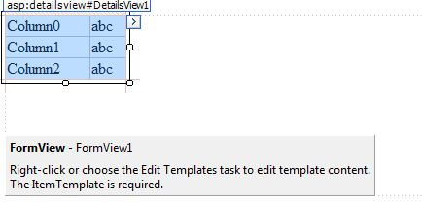

After adding the **controls**,configure the **Data Source property** of these controls in similar manner as explained in **practical 6(a)**

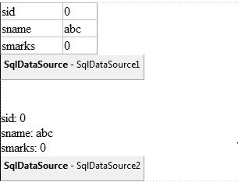

**Output** :

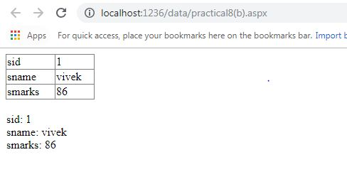

**Practical No.8(c)**

**Problem Statement** :-Create a web application to display Using Disconnected Data Access and Databinding using **Gridview**

**Web.config** :

<?xml version="1.0"?>

<!--

For more information on how to configure your ASP.NET application, please visit

http://go.microsoft.com/fwlink/?LinkId=169433

-->

<configuration>

<system.web>

<compilation debug="true" targetFramework="4.0"/>

</system.web>

<connectionStrings>

<add name="connStr" connectionString="Data Source=.\SQLEXPRESS;AttachDbFilename=D:\sonu\TYIT\data\App_Data\Data.mdf;Integrated Security=True;User Instance=True"></add>

</connectionStrings>

</configuration>

**Source code** :

**Practical8(c).aspx** :

<%@ Page Language="C#" AutoEventWireup="true" CodeFile="practical8(c).aspx.cs" Inherits="practical8_c_" %>

<!DOCTYPE html PUBLIC "-//W3C//DTD XHTML 1.0 Transitional//EN" "http://www.w3.org/TR/xhtml1/DTD/xhtml1-transitional.dtd">

<html xmlns="http://www.w3.org/1999/xhtml">

<head runat="server">

<title></title>

</head>

<body>

<form id="form1" runat="server">

<div>

<asp:Button ID="Button1" runat="server" onclick="Button1_Click"

style="margin-bottom: 0px" Text="Show Disconnected Fetched Data"

Width="210px" />

<br />

<br />

&nbsp;&nbsp;&nbsp;&nbsp;&nbsp;&nbsp;&nbsp;&nbsp;&nbsp;&nbsp;&nbsp;

<br />

&nbsp;&nbsp;&nbsp;&nbsp;&nbsp;&nbsp;&nbsp;&nbsp;&nbsp;&nbsp;&nbsp;&nbsp;&nbsp;

<asp:GridView ID="GridView1" runat="server" AutoGenerateColumns="False"

CellPadding="4" DataKeyNames="sid"

#“Both DataSource and DataSourceID are defined on 'GridView1'. Remove one definition.”

ForeColor="#333333" GridLines="None">

<AlternatingRowStyle BackColor="White" />

<Columns>

<asp:BoundField DataField="sid" HeaderText="sid" ReadOnly="True"

SortExpression="sid" />

<asp:BoundField DataField="sname" HeaderText="sname" SortExpression="sname" />

<asp:BoundField DataField="smarks" HeaderText="smarks"

SortExpression="smarks" />

</Columns>

<FooterStyle BackColor="#990000" Font-Bold="True" ForeColor="White" />

<HeaderStyle BackColor="#990000" Font-Bold="True" ForeColor="White" />

<PagerStyle BackColor="#FFCC66" ForeColor="#333333" HorizontalAlign="Center" />

<RowStyle BackColor="#FFFBD6" ForeColor="#333333" />

<SelectedRowStyle BackColor="#FFCC66" Font-Bold="True" ForeColor="Navy" />

<SortedAscendingCellStyle BackColor="#FDF5AC" />

<SortedAscendingHeaderStyle BackColor="#4D0000" />

<SortedDescendingCellStyle BackColor="#FCF6C0" />

<SortedDescendingHeaderStyle BackColor="#820000" />

</asp:GridView>

<asp:SqlDataSource ID="SqlDataSource1" runat="server"

ConnectionString="Data Source=.\SQLEXPRESS;AttachDbFilename=|DataDirectory|\Data.mdf;Integrated Security=True;User Instance=True"

ProviderName="System.Data.SqlClient" SelectCommand="SELECT * FROM [stud]">

</asp:SqlDataSource>

</div>

</form>

</body>

</html>

**Practical8(c).aspx.cs** :

using System;

using System.Collections.Generic;

using System.Linq;

using System.Web;

using System.Web.UI;

using System.Web.UI.WebControls;

using System.Data;

using System.Data.SqlClient;

using System.Configuration;

public partial class practical8_c_ : System.Web.UI.Page

{

protected void Page_Load(object sender, EventArgs e)

{

}

protected void Button1_Click(object sender, EventArgs e)

{

string connStr = ConfigurationManager.ConnectionStrings["connStr"].ConnectionString;

SqlConnection con = new SqlConnection(connStr);

SqlDataAdapter objDa = new SqlDataAdapter();

DataSet objDas = new DataSet();

using (SqlConnection objConn = new SqlConnection(connStr))

{

SqlCommand objCmd = new SqlCommand("select * from stud", objConn);

objCmd.CommandType= CommandType.Text;

objDa.SelectCommand = objCmd;

objDa.Fill(objDas, "stud");

GridView1.DataSource = objDas.Tables[0];

GridView1.DataBind();

}

}

}

**Design ….practical8**(c):

* 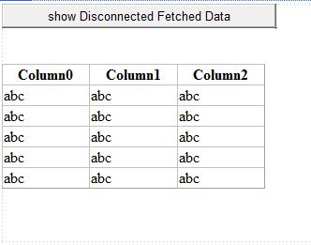

Top of Form

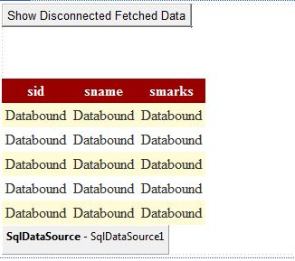

**Output** :

1)

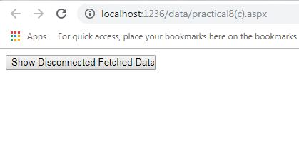

2)

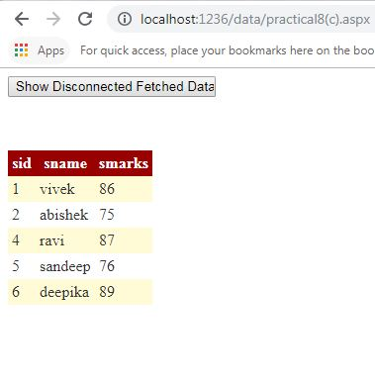

Bottom of Form

Top of Form

  BottTop **Practical No :9(a)**

**Problem statements :Create a web application to demonstrate use of GridView control template and GridView hyperlink**.

**Source code :**

**9a.aspx**

<%@PageLanguage="C#"AutoEventWireup="true"CodeFile="9a.aspx.cs"Inherits="_9a"%>

<!DOCTYPEhtmlPUBLIC"-//W3C//DTD XHTML 1.0 Transitional//EN""http://www.w3.org/TR/xhtml1/DTD/xhtml1-transitional.dtd">

<htmlxmlns="http://www.w3.org/1999/xhtml">

<headrunat="server">

<title></title>

</head>

<body>

<formid="form1"runat="server">

<div>

<asp:GridViewID="GridView1"runat="server"AutoGenerateColumns="False"

DataSourceID="SqlDataSource1">

<Columns>

<asp:HyperLinkFieldDataTextField="sid"HeaderText="Student Id"

NavigateUrl="~/7a.aspx"/>

<asp:BoundFieldDataField="sname"HeaderText="Student Name"

SortExpression="sname"/>

<asp:BoundFieldDataField="smarks"HeaderText="Student Marks"

SortExpression="smarks"/>

</Columns>

</asp:GridView>

<asp:SqlDataSourceID="SqlDataSource1"runat="server"

ConnectionString="<%$ConnectionStrings:ConnectString%>"

SelectCommand="SELECT * FROM [student]"></asp:SqlDataSource>

</div>

</form>

</body>

</html>

**Design….9(a)**

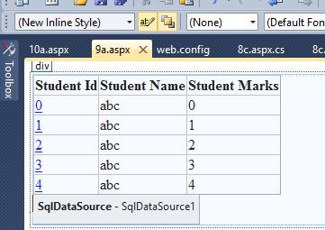

**Output:**

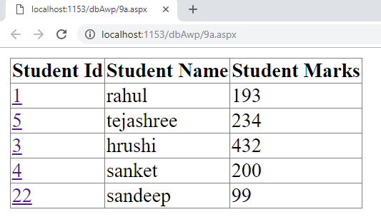

**Practical No.10(a)**

**Problem statements :** Create a web application to demonstrate reading and writing operation with XML.

Add -> new Item -> Xml file

1. **abc.xml**

Keep this file is empty for writing purpose

**Source code :**

**10(a).apsx**

<html xmlns="http://www.w3.org/1999/xhtml">

<head runat="server">

<title></title>

</head>

<body>

<form id="form1" runat="server">

<div>

<asp:Label ID="Label1" runat="server" Text="Label"></asp:Label>

<br />

<br />

<asp:Button ID="Button1" runat="server" OnClick="Button1_Click" Text="xml writer" />

<br />

<br />

<asp:ListBox ID="ListBox1" runat="server" Height="175px"

Width="220px"></asp:ListBox>

<br />

<br />

<asp:Button ID="Button2" runat="server" OnClick="Button2_Click" Text="xml reader" />

<br />

</div>

</form>

</body>

</html

**Design**:

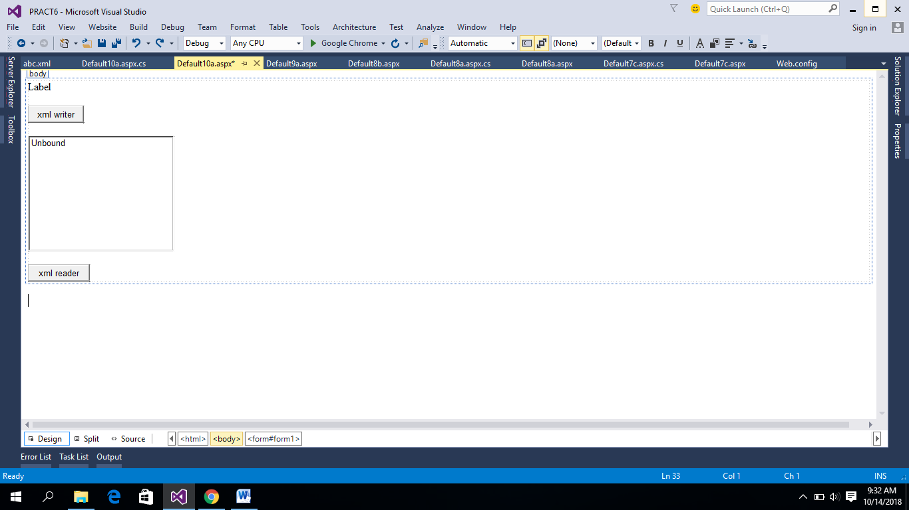

**10a.aspx.cs**

using System;

using System.Collections.Generic;

using System.Linq;

using System.Web;

using System.Web.UI;

using System.Web.UI.WebControls;

**using System.Xml;**

public partial class Default4 : System.Web.UI.Page

{

protected void Page_Load(object sender, EventArgs e)

{

}

protected void Button1_Click(object sender, EventArgs e)

{

XmlTextWriter writer = new XmlTextWriter("E:\\kiran more\\Ganpati

Vacation\\PRACT6\\abc", null);

writer.WriteStartDocument();

writer.WriteStartElement("names");

writer.WriteElementString("name", "kiran");

writer.WriteElementString("name", "pramod");

writer.WriteEndElement();

writer.WriteEndDocument();

writer.Close();

Label1.Text = "Data written successfully";

}

protected void Button2_Click(object sender, EventArgs e)

{

ListBox1.Items.Clear();

XmlTextReader red =new XmlTextReader("E:\\kiran more\\Ganpati

Vacation\\PRACT6\\abc");

while (red.Read())

{

if (red.NodeType == XmlNodeType.Element)

{

if (red.Name == "name")

{

ListBox1.Items.Add(red.ReadString());

}

}

}

red.Close();

}

}

**Output:**

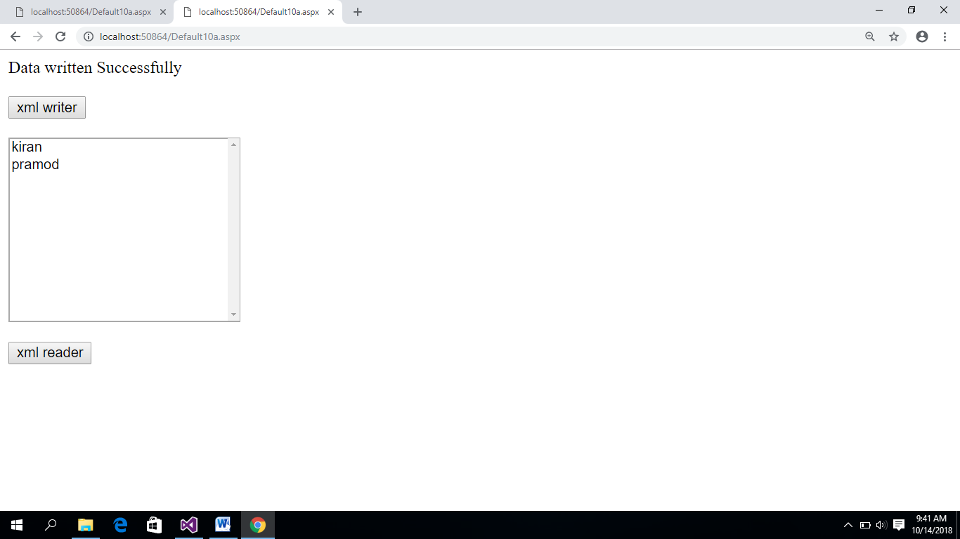

Bottom of Form

**Practical no 11**

**Problem statement: Programs to create and use DLL**

**Steps for add classlibrary.file**

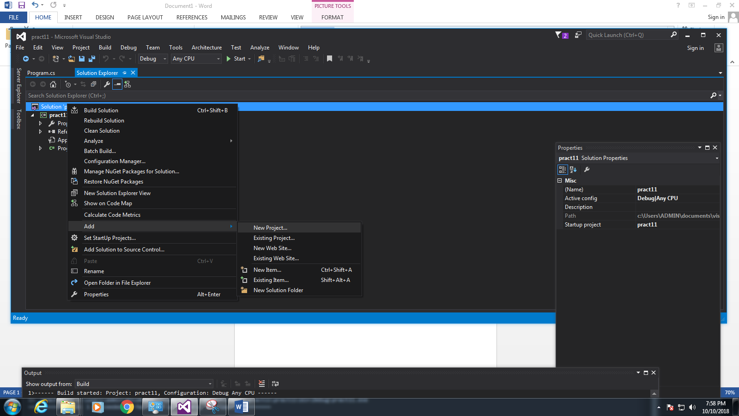

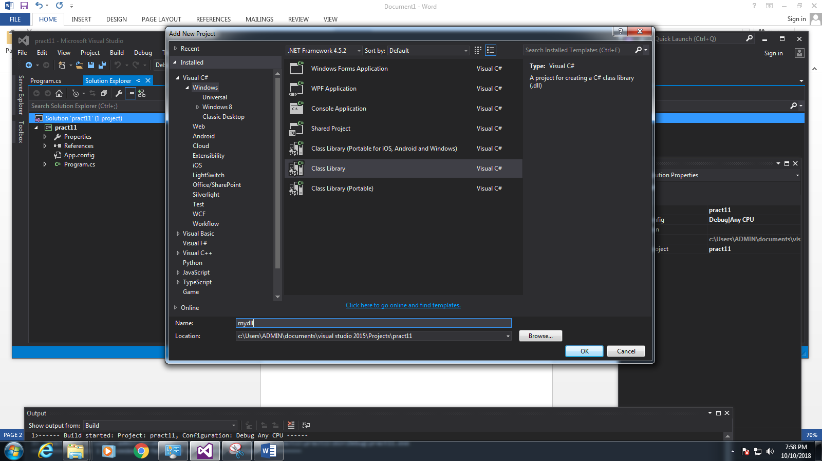

**Steps for add reference to pract11**

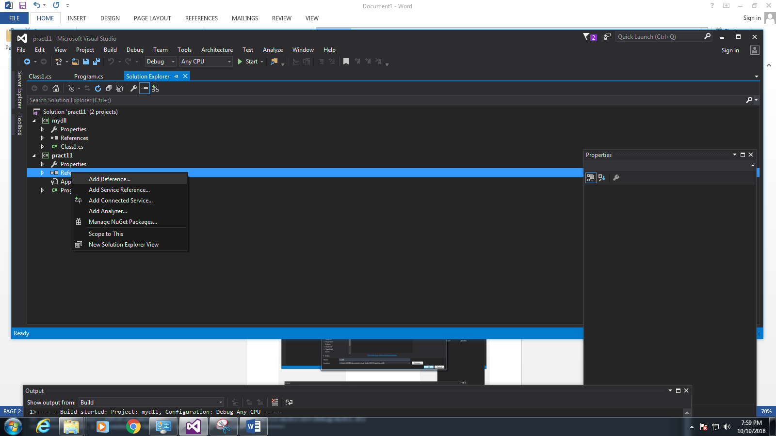

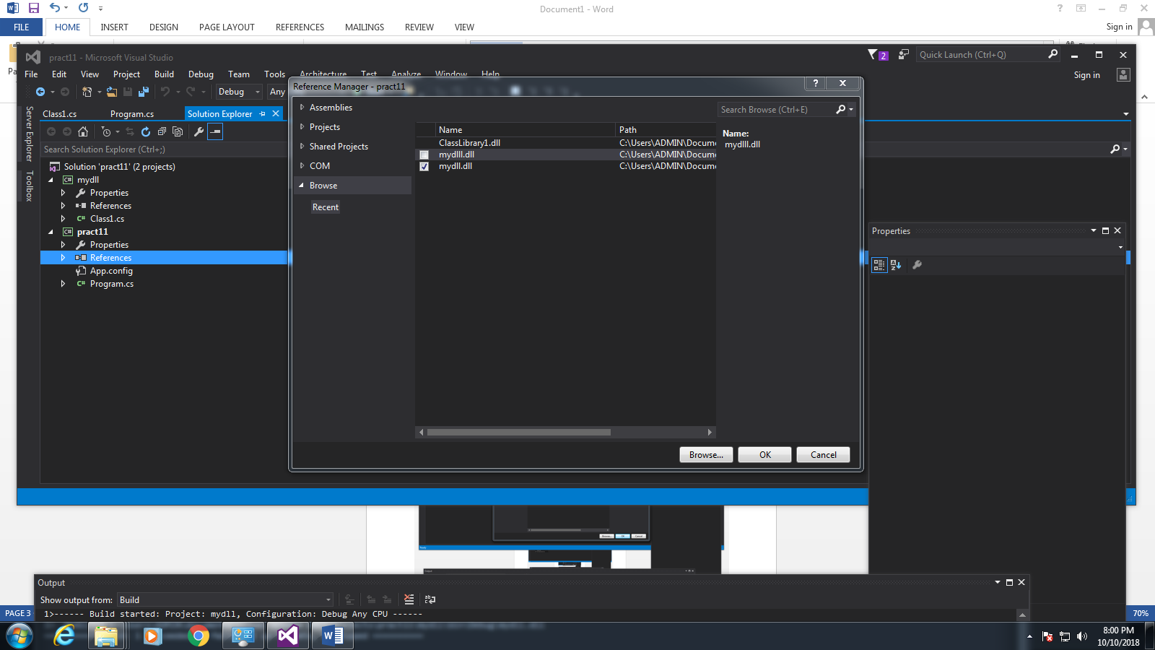

**Source Code:Program.cs**

using System;

using System.Collections.Generic;

using System.Linq;

using System.Text;

using System.Threading.Tasks;

**using mydll;**

namespace pract11

{

class Program

{

static void Main(string[] args)

{

Class1 c = new Class1();

Console.WriteLine(c.disp());

Console.WriteLine("hello");

Console.ReadKey();

}

}

}

**Source Code:Class1.cs**

using System;

using System.Collections.Generic;

using System.Linq;

using System.Text;

using System.Threading.Tasks;

namespace mydll

{

public class Class1

{

public string disp()

{

return "This is dll file";

}

}

}

**Output:**

